**Tag** = contains opening and closing

**Element** = contains the pair of tag and the content

**Do's**

* Only 1 Header 1 is recommended.
* If you already have H1 make use the next header format

**Don'ts**

* Skip from H1 to H2-onwards or vice versa

Using paragraph automatically created space in between them for readability purpose.

If you want to simulate a sample content use the lorem ipsum text [*www.lipsum.com*](http://www.lipsum.com)

**Void element are the ff:**

* *hr*
* *br*

You can tell that it is a void element if you are not allowed to place a content on it

**Don't**

*<p>*

Paragraph 1*<br />*

Paragraph 2*<br />*

*</p>*

**Do**

*<p>Paragraph 1</p>*

*<p>Paragraph 2</p>*

use only *<br>* if you have the reason to break a single paragraph.

*HTML 5* **accepts** the *<br>* and *<hr>* tags but some recommendations says that we need to use the *< />* format

**Unordered** *<ul>* **vs. Ordered** *<ol>* **Lists**

*ul* is used if there is no step-by-step process or sequential part of your list, while *ol* is used to list the item in sequential order.

*<img src='url' />* is also a void element

*alt* or alternative text is a must to an *img* attribute

Some ommit the **./** and just declare the file that need to the code but the good practice is always append it.

There are two types of path

* Absolute
* Relative
* **DOCTYPE** specify what version of HTML will you use.
* **lang** in html tag is set for the assistive tool to pronounce the content correctly.
* **head** tag is not displayed and this contains the information for your website.
* **charset** attribute ensure that the characters displayed in your content is correct.
* **title** tag is the one we see on the tab of a browser.
* **body** tag is where we write the content of our website.
* **viewport** tells what should the website look like on the screen.

**Types of selectors:**

*Element selector*

h1 {

CSS Code

}

*Class selector*

.red-heading {

CSS Code

}

*ID selector*

#red-heading {

CSS Code

}

*Attribute selector*

p[draggable] {

CSS Code

}

p[draggable='false'] {

CSS Code

}

*Universal selector*

* {

CSS Code

}

**Properties**

*1px (Pixel)* = 1/96 inch or 0.26mm

*1pt (Point)* = 1/72nd inch 0.35mm

*1em* = 100% of parent (size of the full with of an "m")

*1rem* = 100% of root (Relative)

Recommended to use over *em* and *rem* is the REM

**Font Weight**

normal / bold = Keywords

lighter / bolder = Relative to parent

number = 100 to 900

**Pesticide chrome extension** is very useful: after closing the inspect element just hold the CTRL key to view what element you're hovering over

**Types of Cascading**

1. Position
2. Specificity
   * element selector
   * class selector
   * attribute selector
   * id selector (This is the most priority of all)
3. Type
   * External
   * Internal
   * Inline (Most important)
4. Importance
   * adding ***!important***

**Combining CSS Selector:**

1. Group
   * selector, selector {}
2. Child
   * selector > selector {}
   * This is one generation deep.
   * The direct child
3. Descendant
   * *selector* *selector* {}
4. Chaining
   * *selectorselector* {}
   * Apply where all selector is true.
5. Combining Combiners
   * *selector* *selectorselector*{}

**CSS Positioning**

1. Static (HTML Default)
   * HTML Default flow
2. Relative
   * Position relative to default position
3. Absolute
   * Position relative to nearest positioned ancestor or top left corner of the webpage
   * *z-index* determine which should be on **top**
4. Fixed
   * position relative to top left corner of browser window

**CSS Display**

Block, Inline, Inline-Block

* span has default value inline.
* most element has a display value block.
* block covers the entire full width of the site
* element with inline display cannot be set the height and width. It will fill the width unlike it cover all then it will go to next line.
* span is an inline element. It has no width or height.

You could turn it into a block-level element, then it will accept your dimension directives.

* inline-block = can be set the height and width while going to the same line
* none = can make the element disappear to the site.

**Float** - Wrap text using float and clear.

* set the float property to the element you want to wrap around of another element.
* you can set the float property either left or right
* you can avoid element to float together by setting the property to clear then chose if left or right or both
* In the old days developers always use the float property to create a complex design
* **IMPORTANT NOTE:** only use float if you want to wrap text around an image

**CSS Responsive Web Development:**

1. Media Query
   * @media (max-width: 600px) {code here}
2. Flexbox
   * display: flex;
   * a lot more flexible
   * 1 dimension layout
   * flex property makes the element have an equal width.
3. CSS Grid (Hard to understand but more flexible)
   * display: grid;
   * got columns and rows
   * 1fr == 1 fraction
4. External Frameworks: e.g., Bootstrap

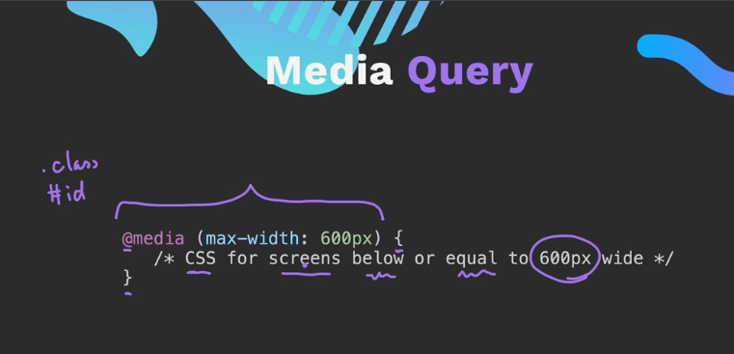

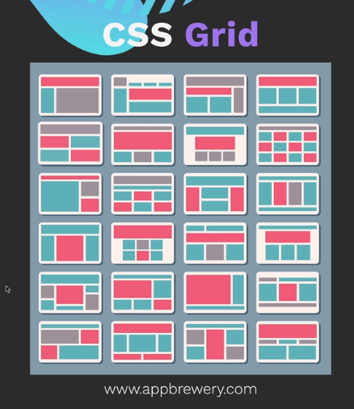

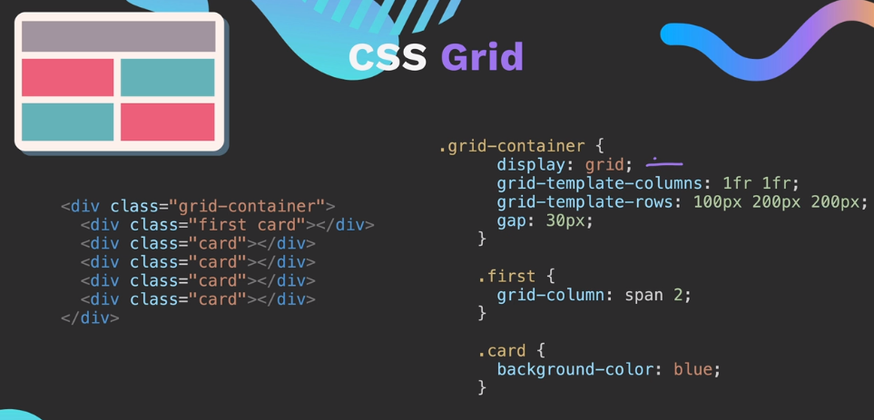

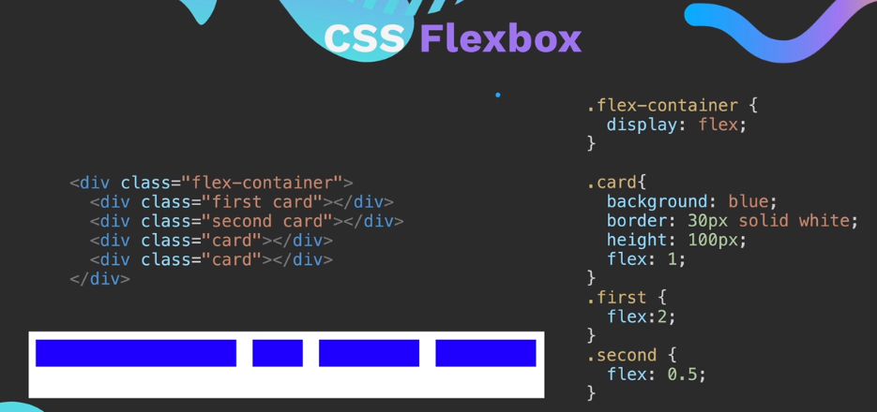

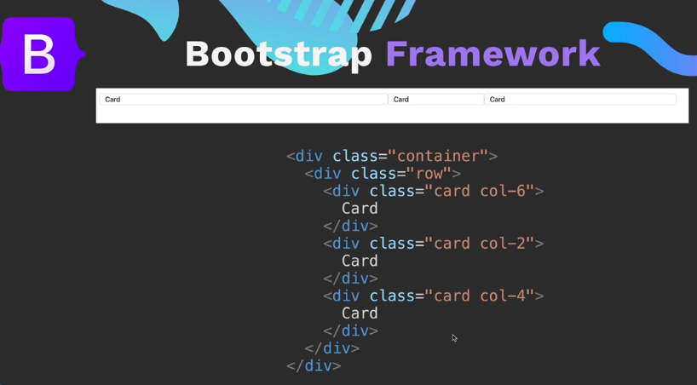

**Media Query:**

600px below:

@media (max-width: 600px) {

h1 {

font-size: 15px;

}

}

600px above:

@media (min-width: 600px) {

h1 {

font-size: 15px;

}

}

Combination

@media (min-width: 600px) and (max-width: 900px){

/* styles the screen between 600 and 900px */

}

@media (max-width: 600px) and (min-width: 900px){

/* styles the screen less than 600 and greater than 900px */

}

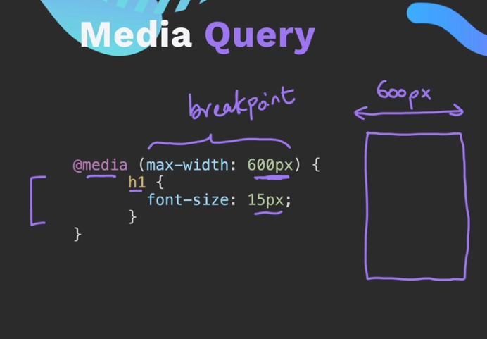

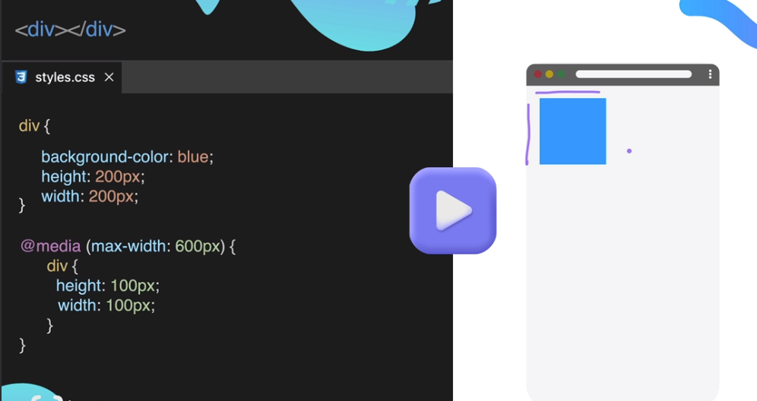

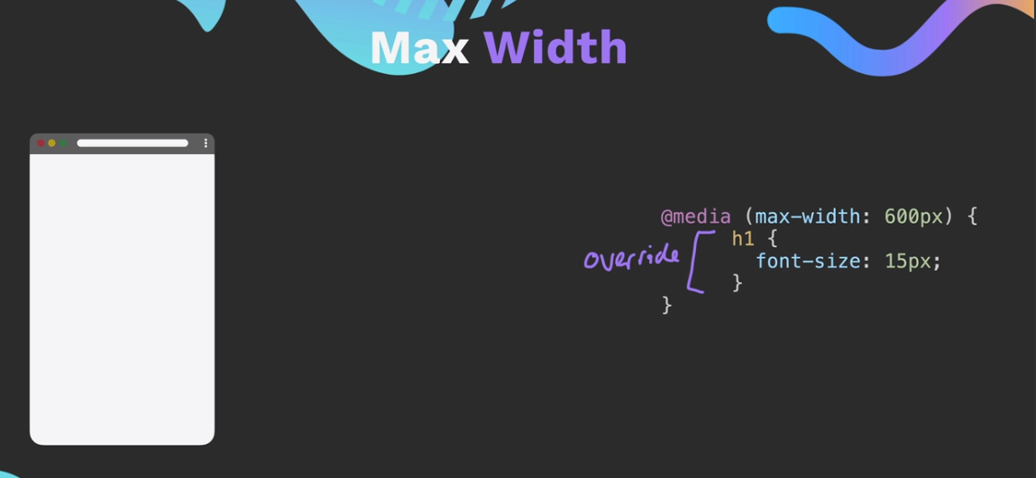

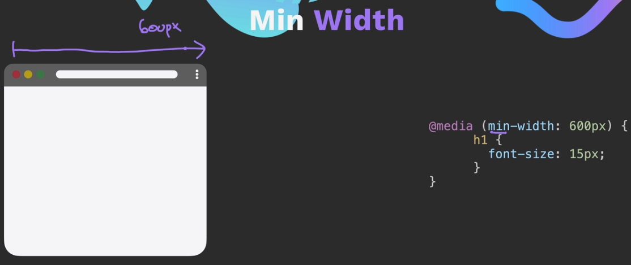

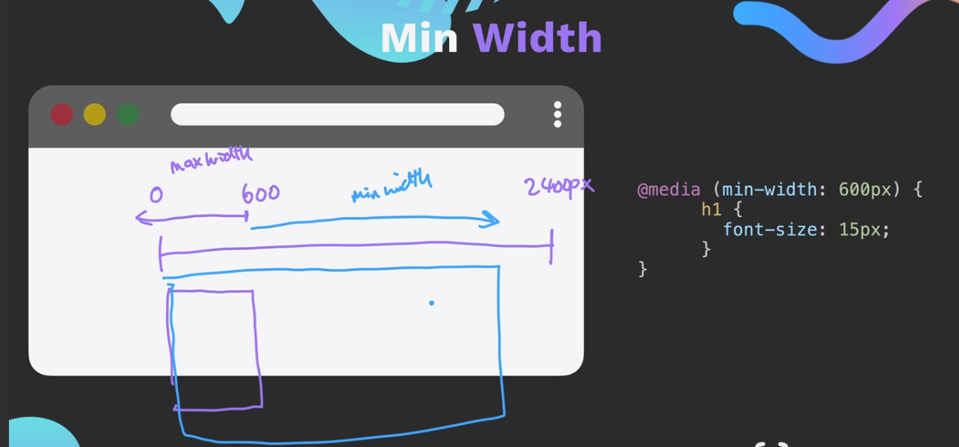

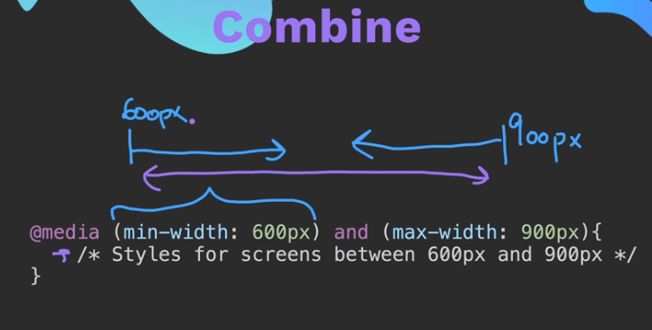

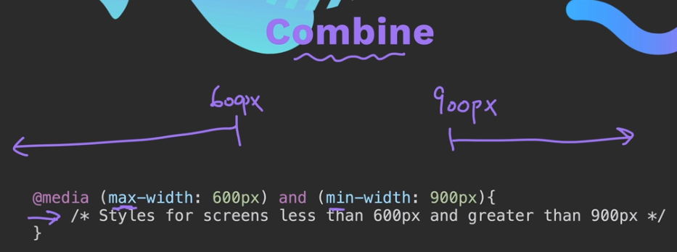

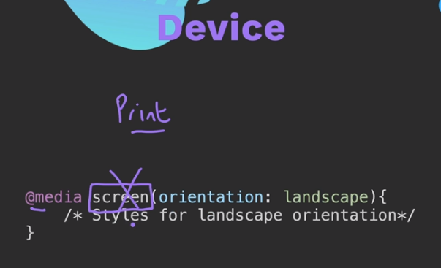

**Flexbox**

Float is **great** if you want to *float an image to the left or right of block of text*. But **do not use** it for **layout**

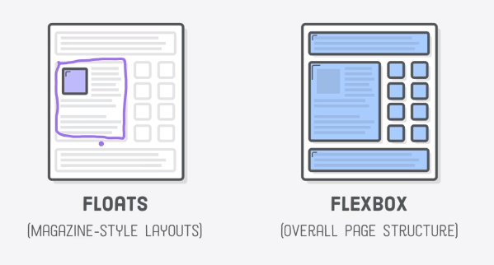

*Flexbox, Grid and Bootstrap is best for layout*

Although flex is in the *display property*, the inline, block, inline-block and none system is **different** from it.

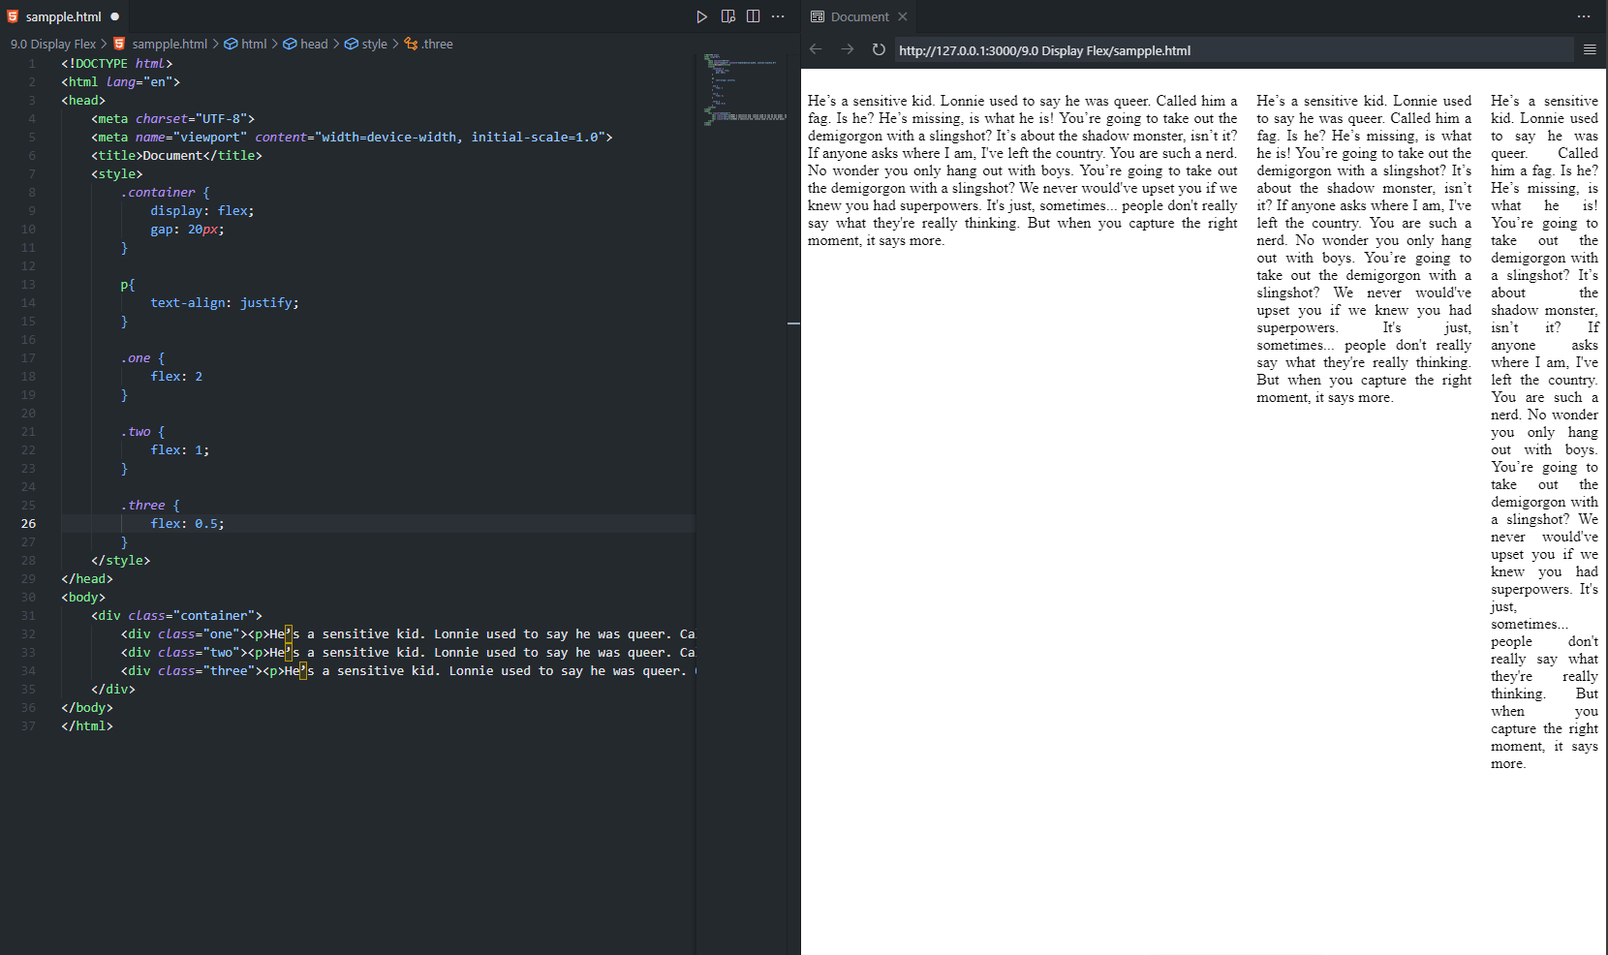

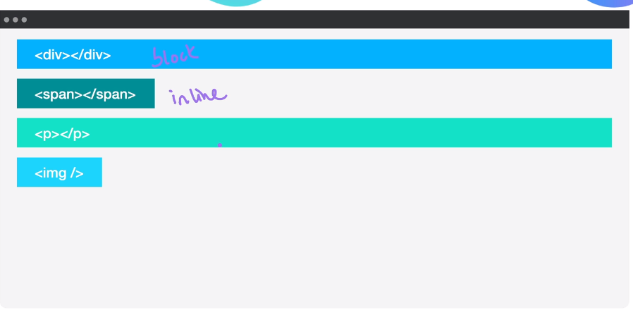

Using flexbox the display example of the above image will be ignored and the below image will show.

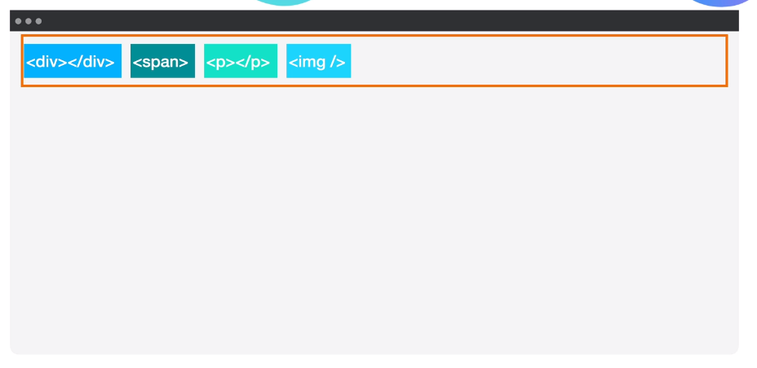

*gap* property sets the gap of each element

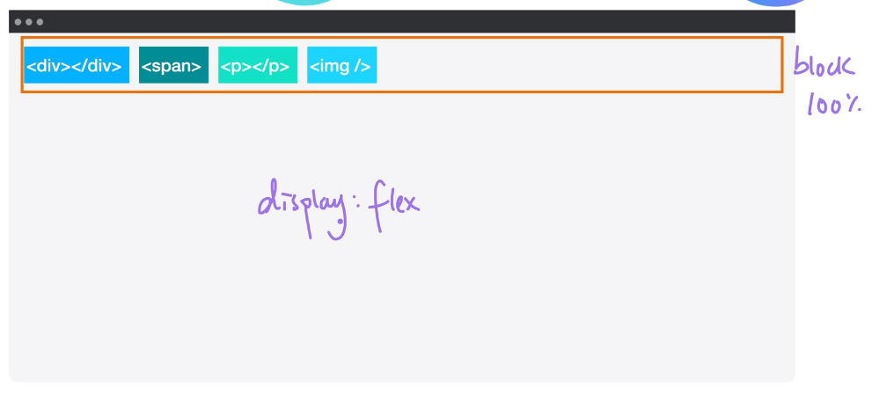

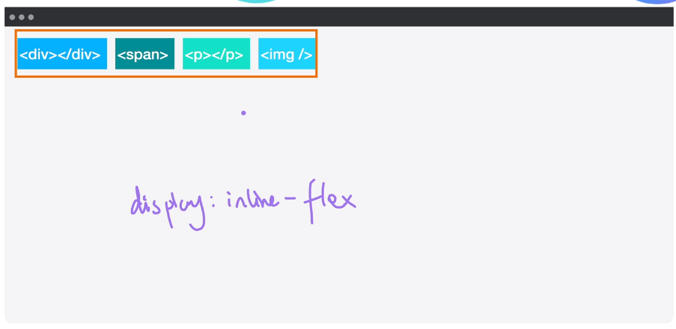

**Flex: Direction**

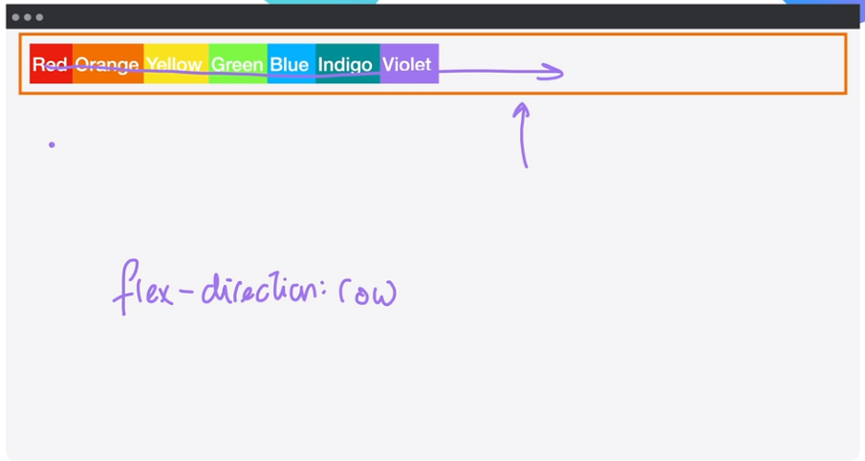

Default value of flex-direction is row

Main-axis is horizontal left to right.

Cross-axis if vertical top to bottom.

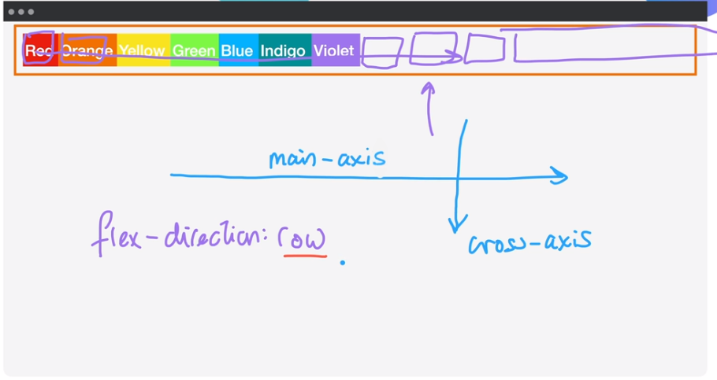

When flex-direction is set to column the main-axis will be from top to bottom. And the cross axis is left to right.

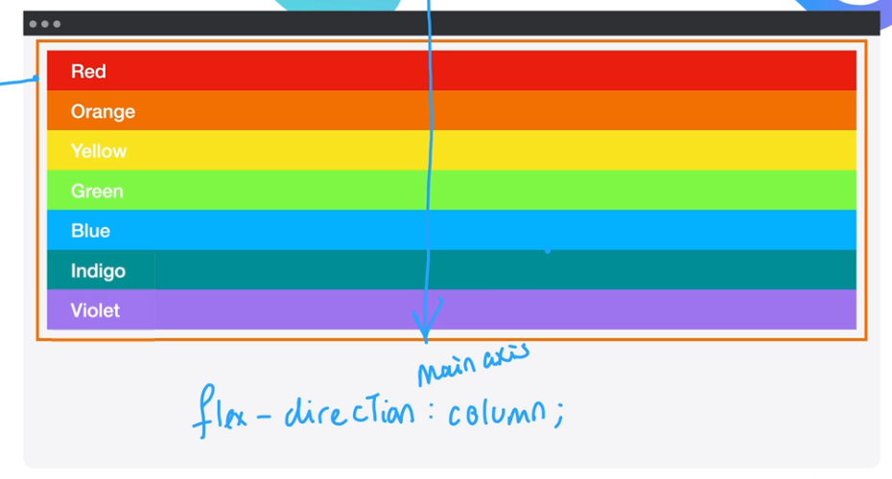

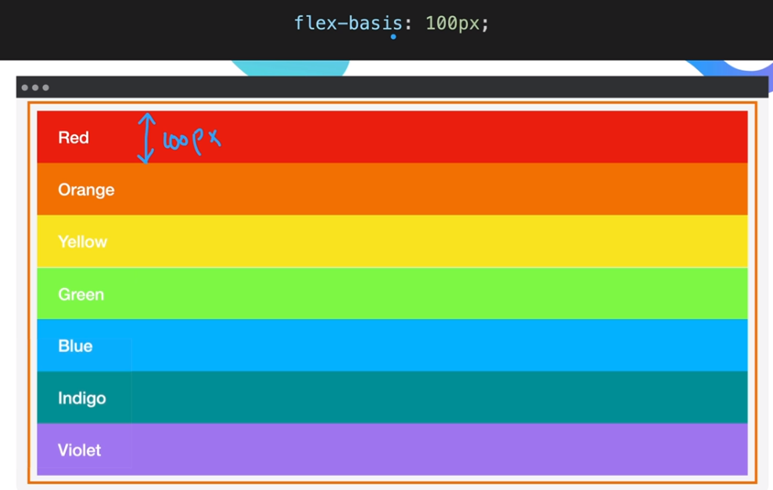

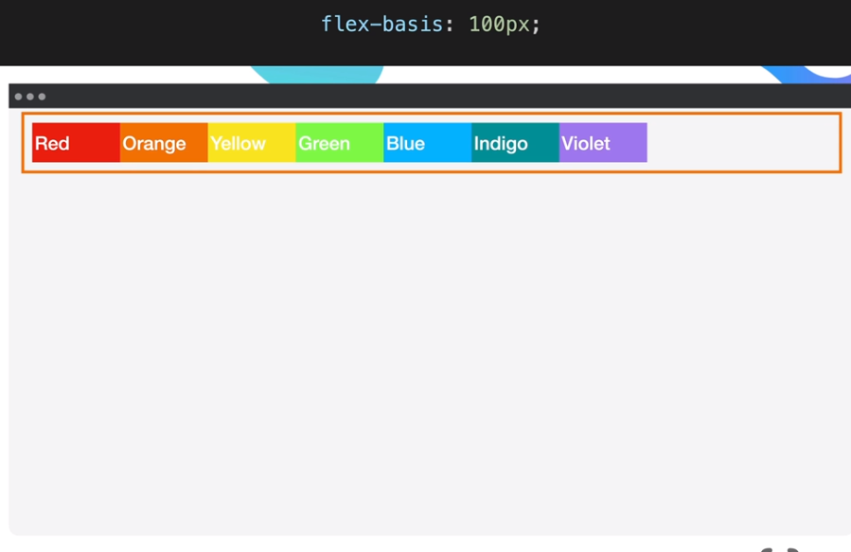

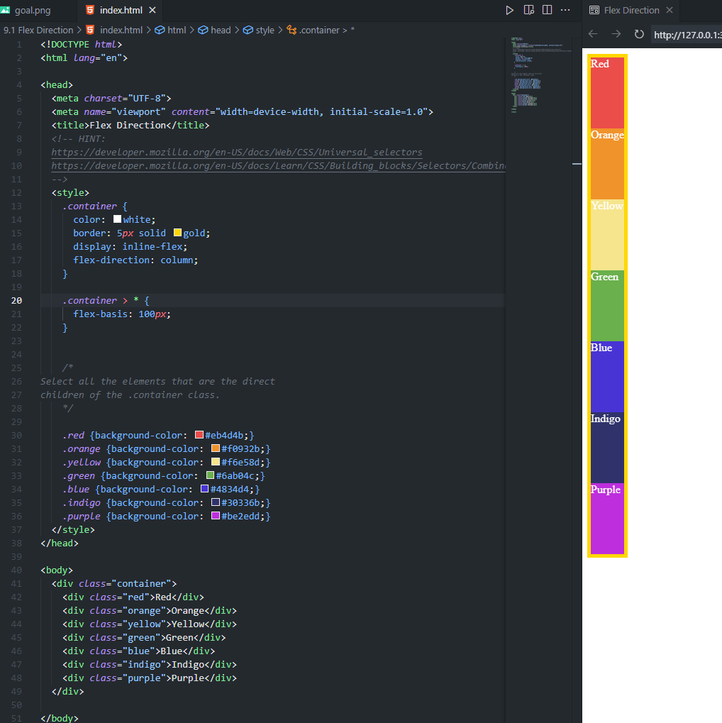

**Flexible: Layout**

Align, Justify, and Wrap

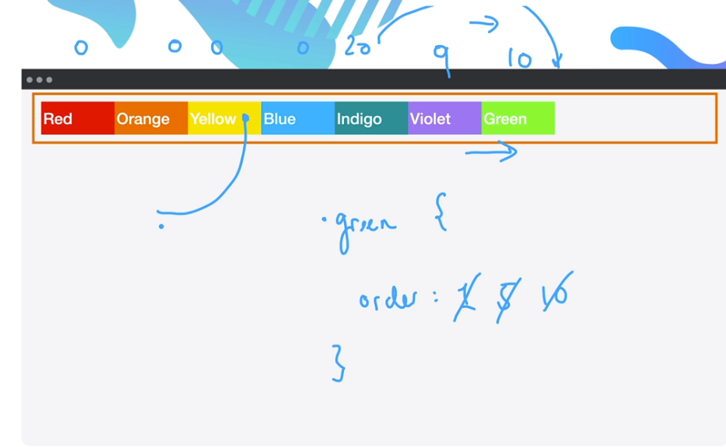

***order*** property sets the arrangement of the elements

**flex-wrap**: nowrap; (Default behavior)

useful when you run out of space on the horizontal

set always in the **container**

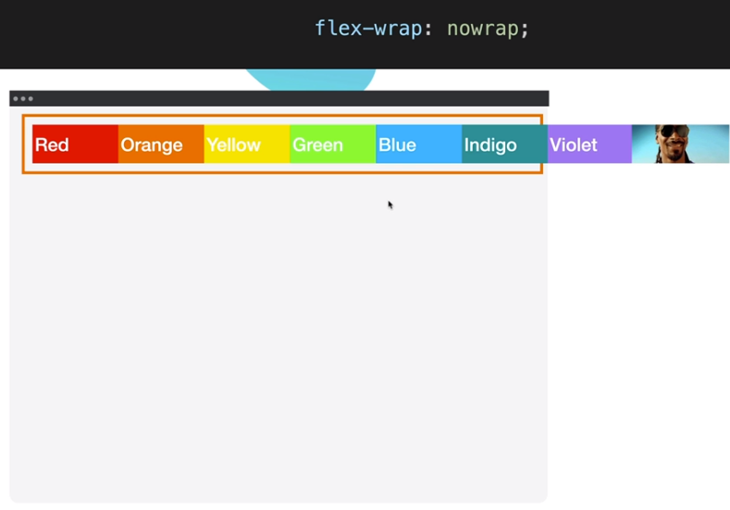

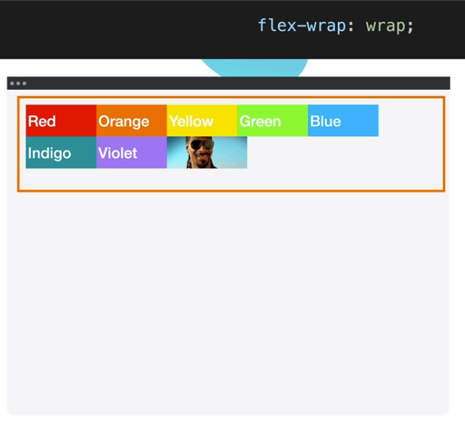

Reference: [Flex Layout (appbrewery.github.io)](https://appbrewery.github.io/flex-layout/)

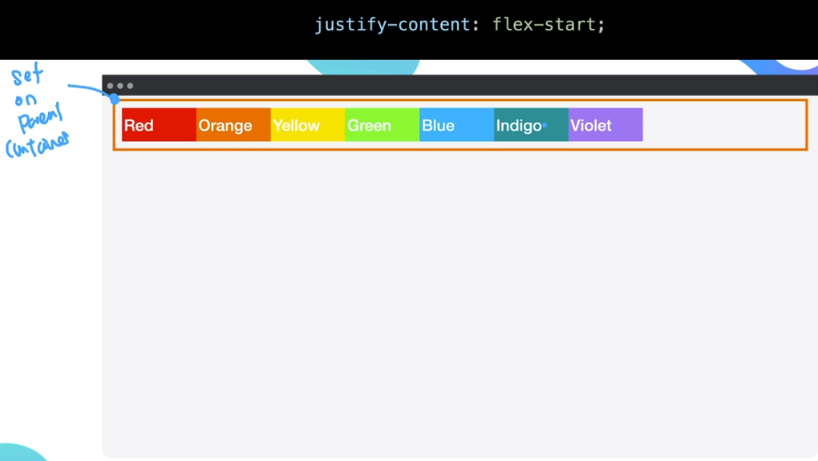

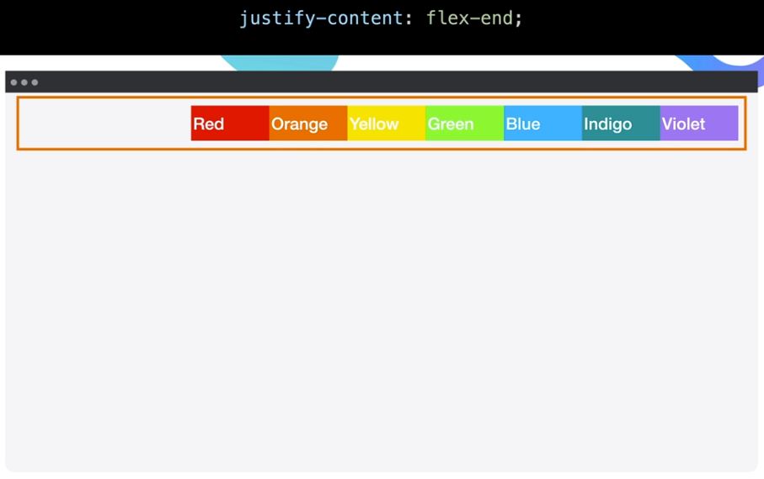

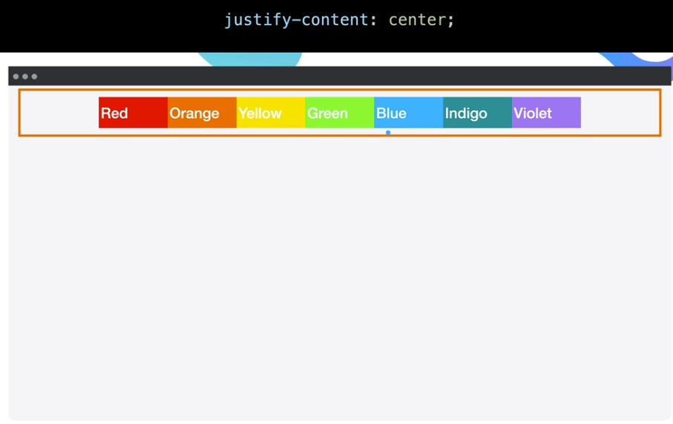

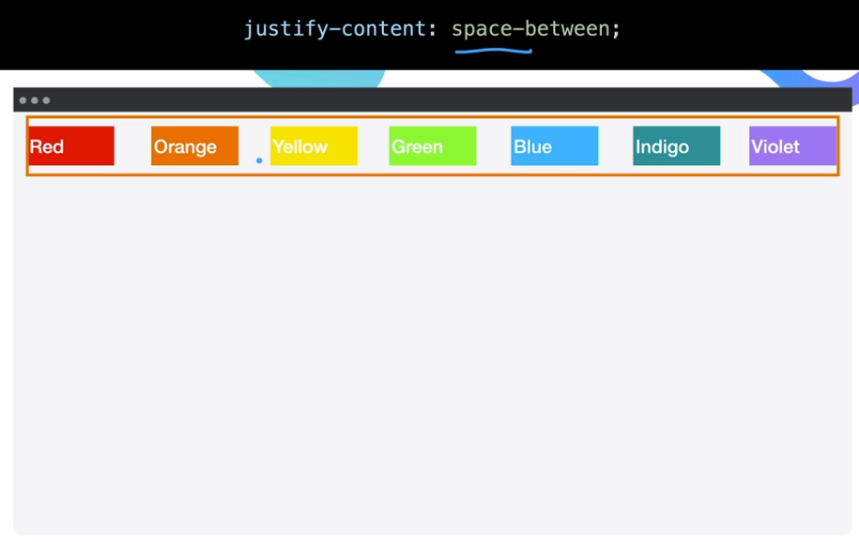

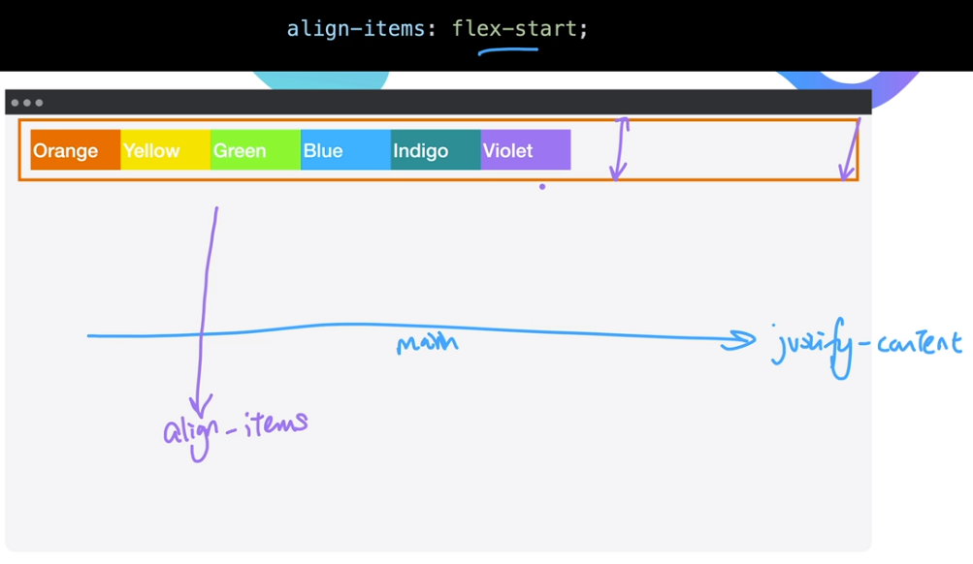

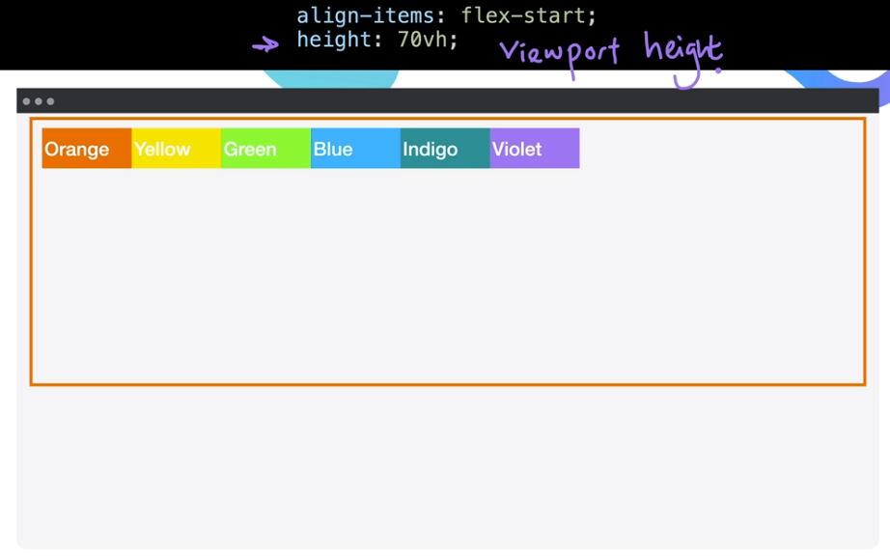

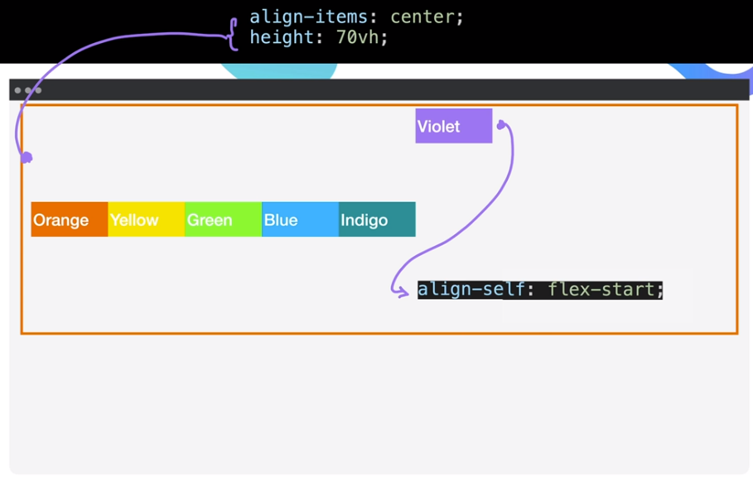

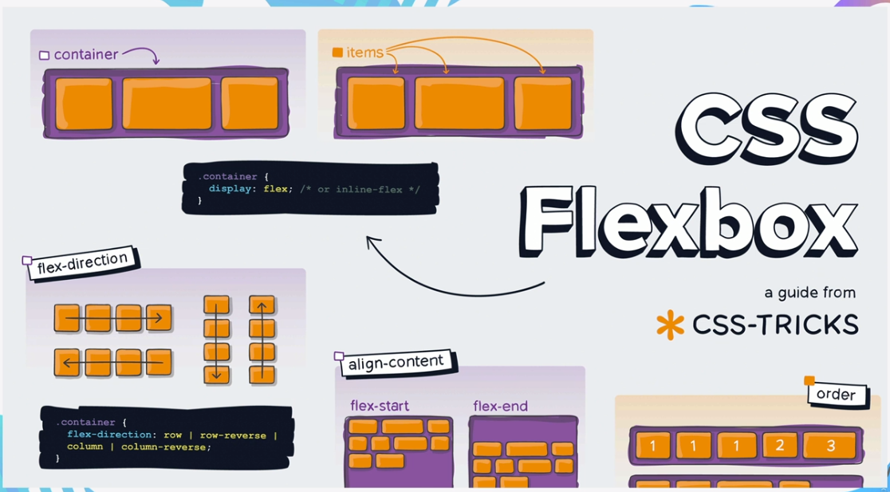

[A Complete Guide to Flexbox | CSS-Tricks - CSS-Tricks](https://css-tricks.com/snippets/css/a-guide-to-flexbox/)

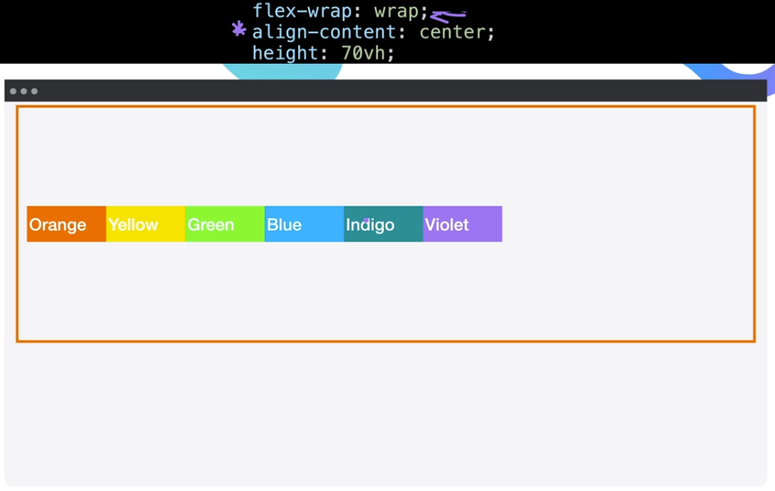

[Flexbox Froggy - A game for learning CSS flexbox](https://flexboxfroggy.com/)

**Flex-Sizing: Shrinking and Growing**

Priority list

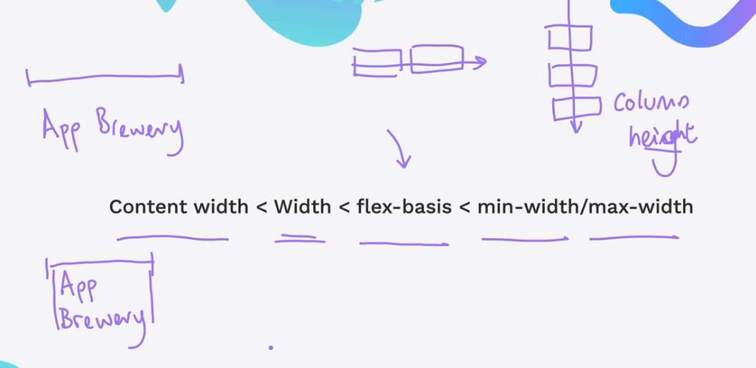

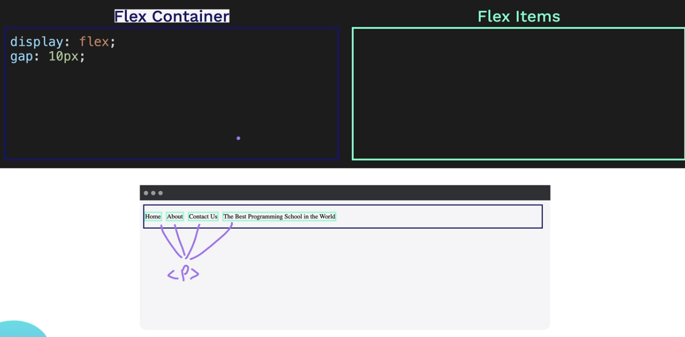

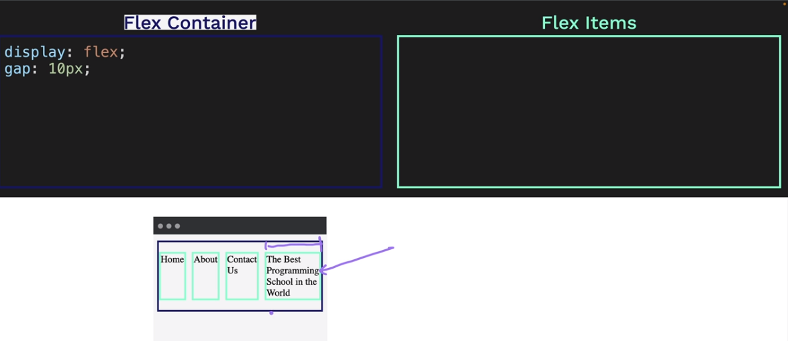

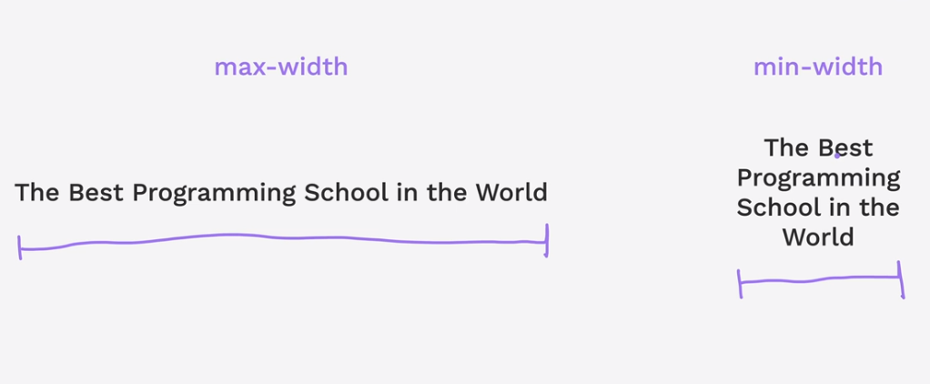

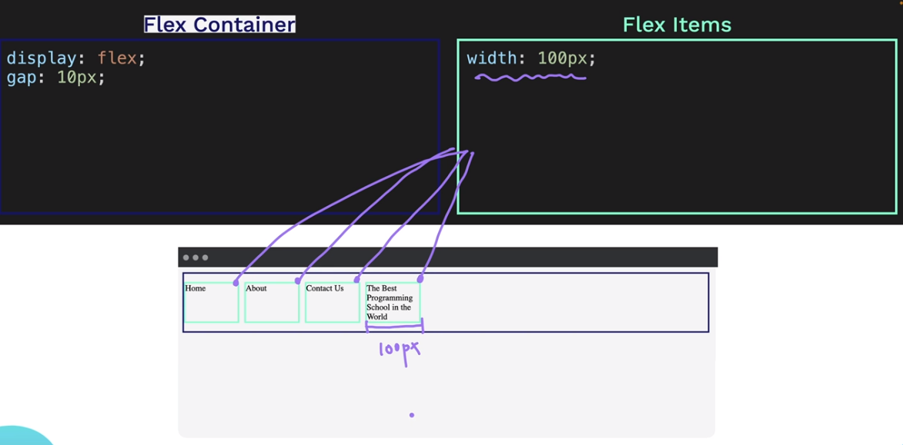

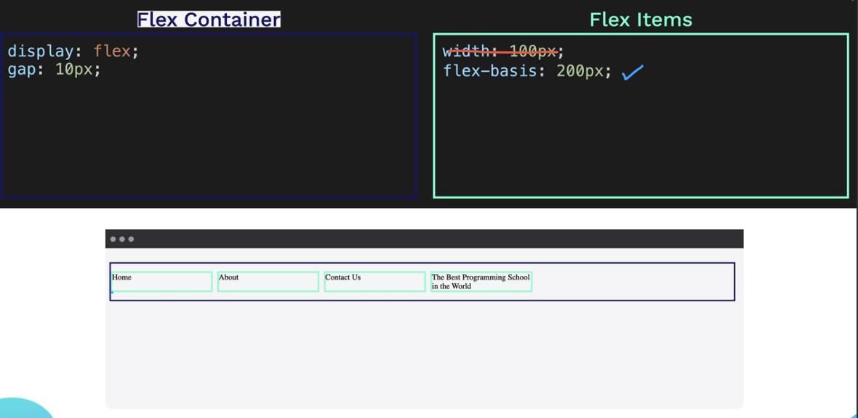

**max-width** will override the *flex-basis*

If **flex-basis** is lower than the *max-width*. The **flex-basis** will override the *max-width.*

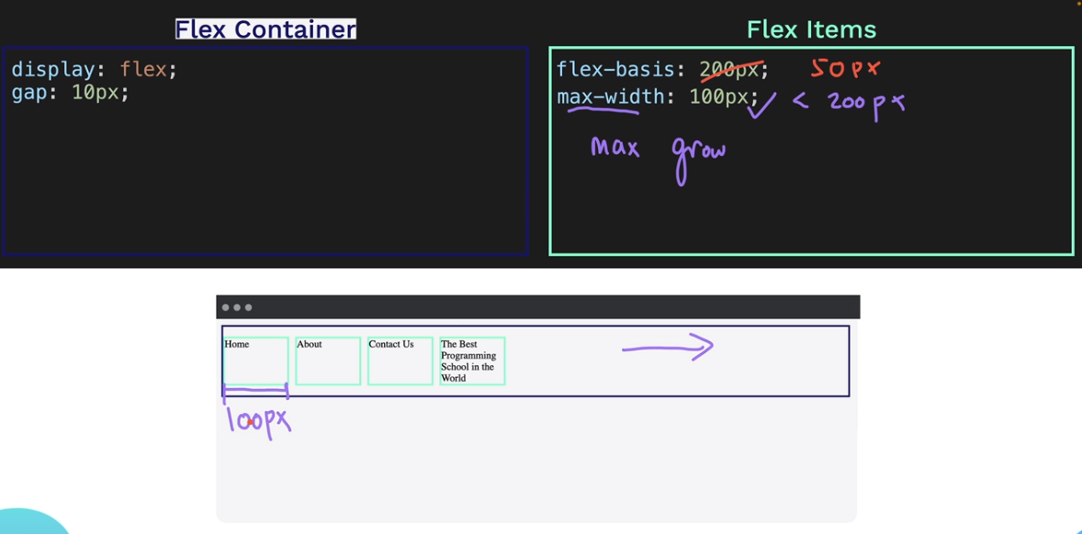

**min-width** will override the *flex-basis*

*if* ***minimum-width*** *is larger than* ***flex-basis*** *it will respect the* ***minimum-width***

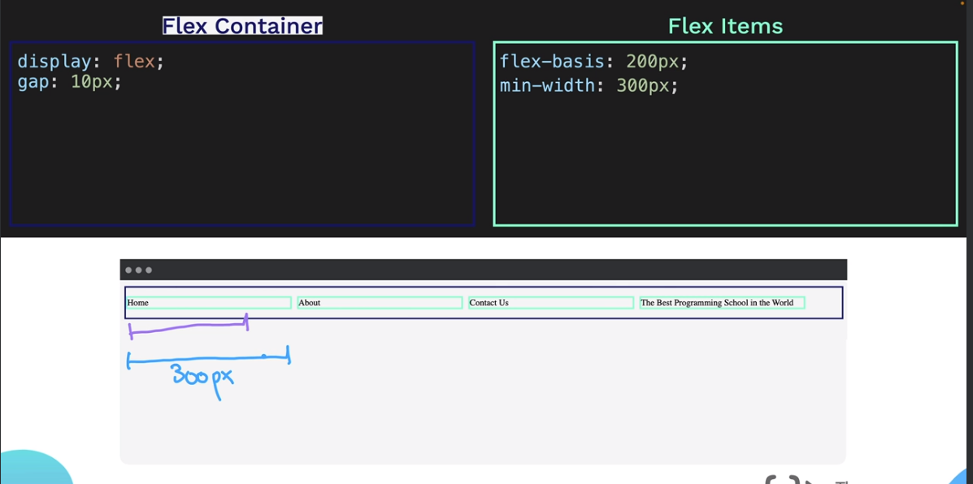

Setting flex-grow and flex-shrink to 0 will tell the program that it will not grow nor shrink.

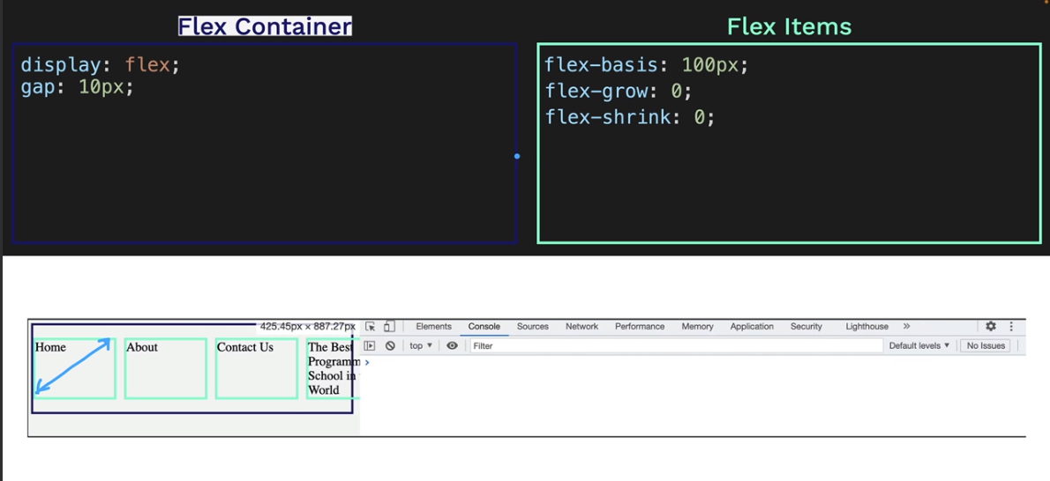

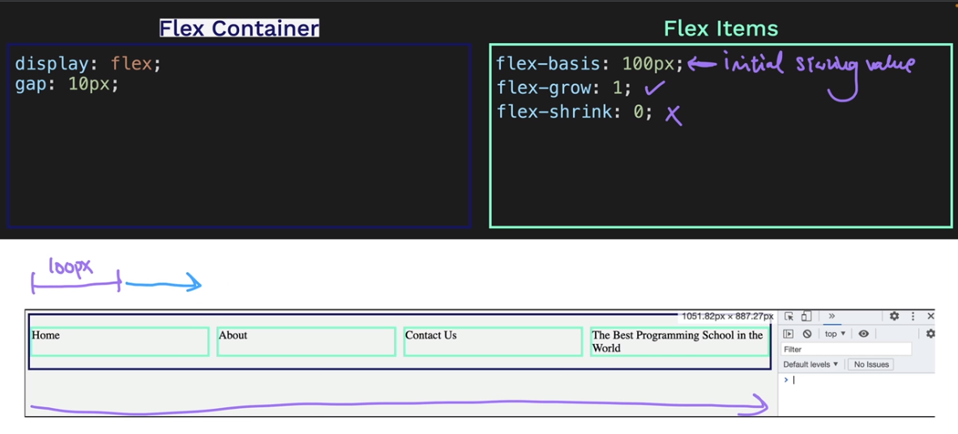

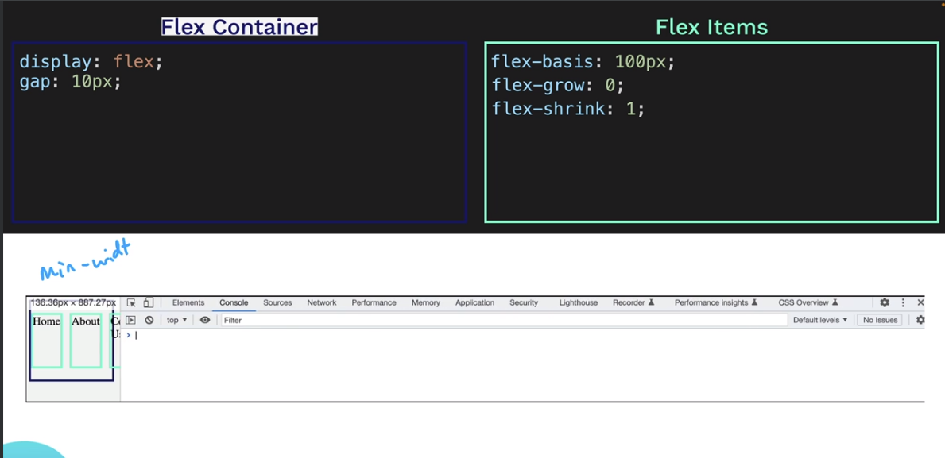

Since flex-grow and flex-width is set to on, it will ignore the flex-basis.

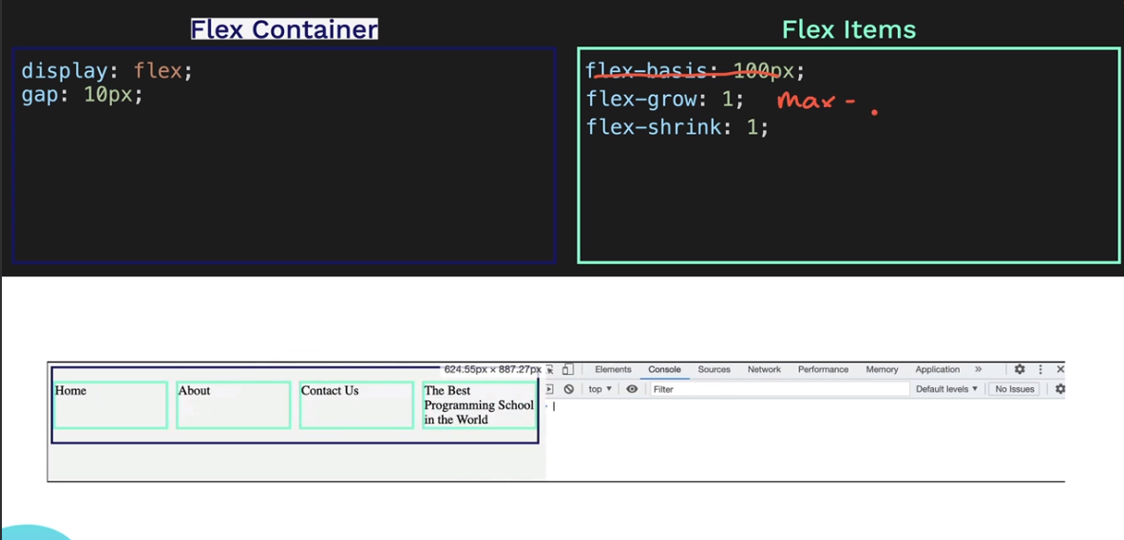

*flex-basis* **default** value is **auto**.

There is a short hand of setting the flex basis, shrink and grow.

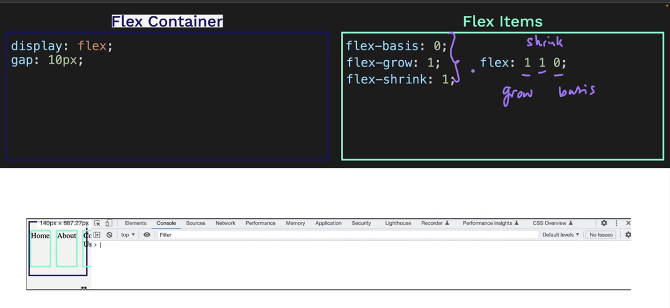

[Flexbox Sizing Exercise (appbrewery.github.io)](https://appbrewery.github.io/flexbox-sizing-exercise/)

**CSS GRID: A Two-Dimensional Layout System**

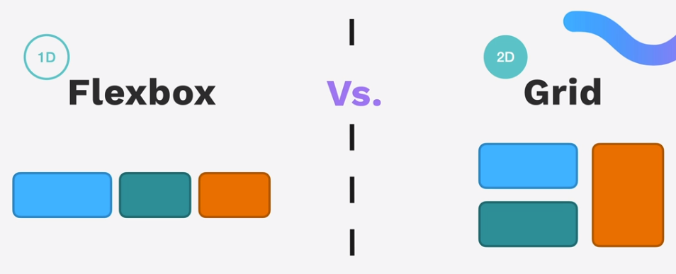

We can manage to do this using flex-box

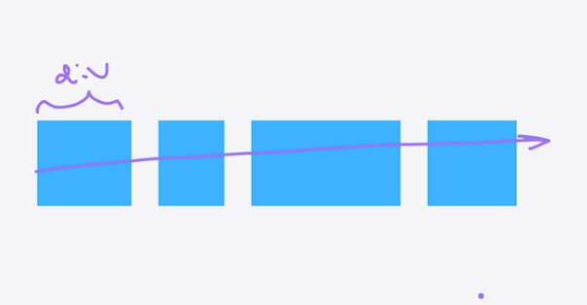

But for this one we need the **GRID SYSTEM**



Flex-box is for alignment of content (1D), while Grid is used for laying out the content along a 2D Grid

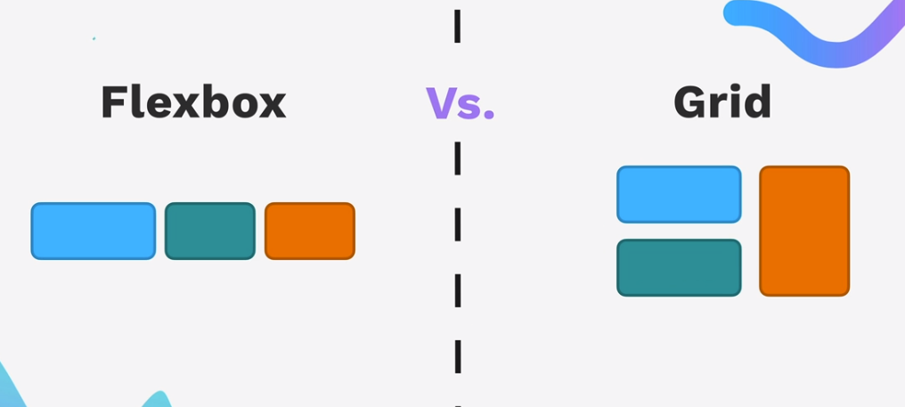

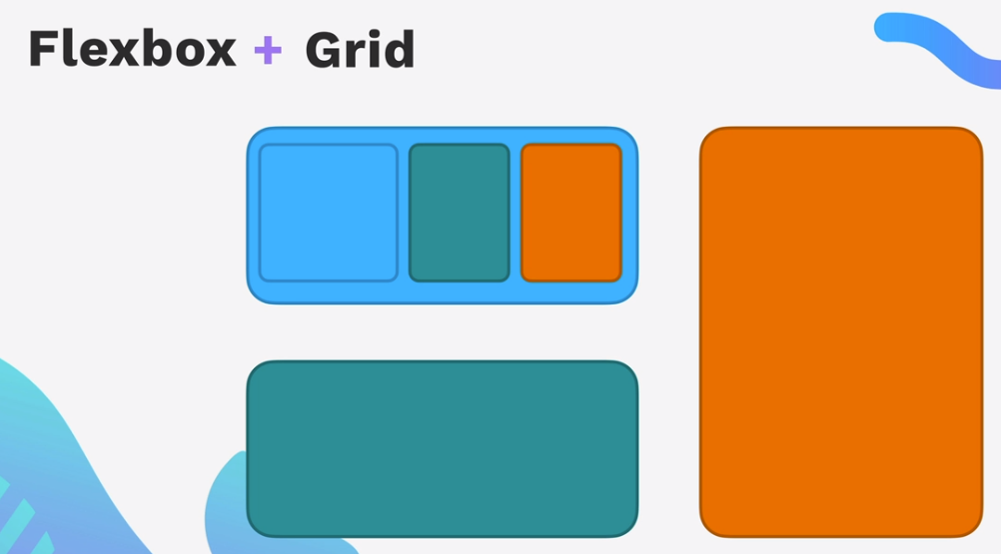

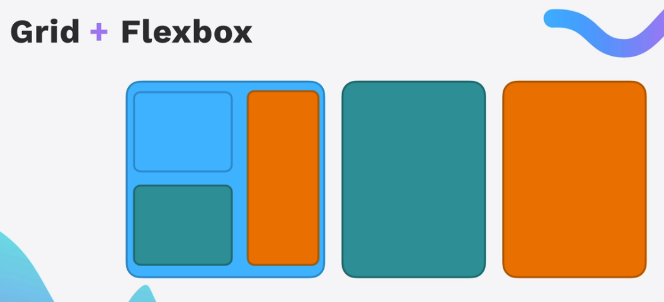

[CSS Grid vs Flexbox (appbrewery.github.io)](https://appbrewery.github.io/grid-vs-flexbox/)

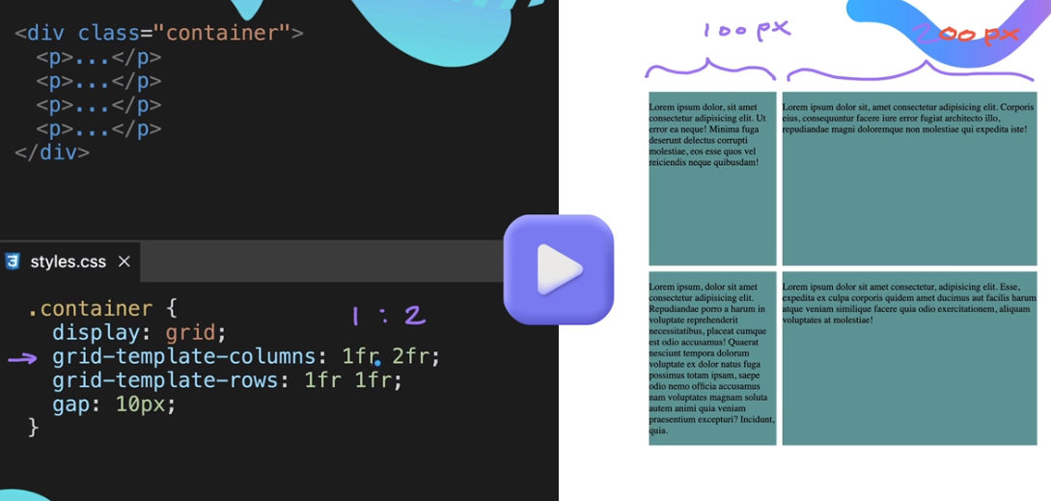

Above is sample of Grid

Exercise for Grid: Chess Board

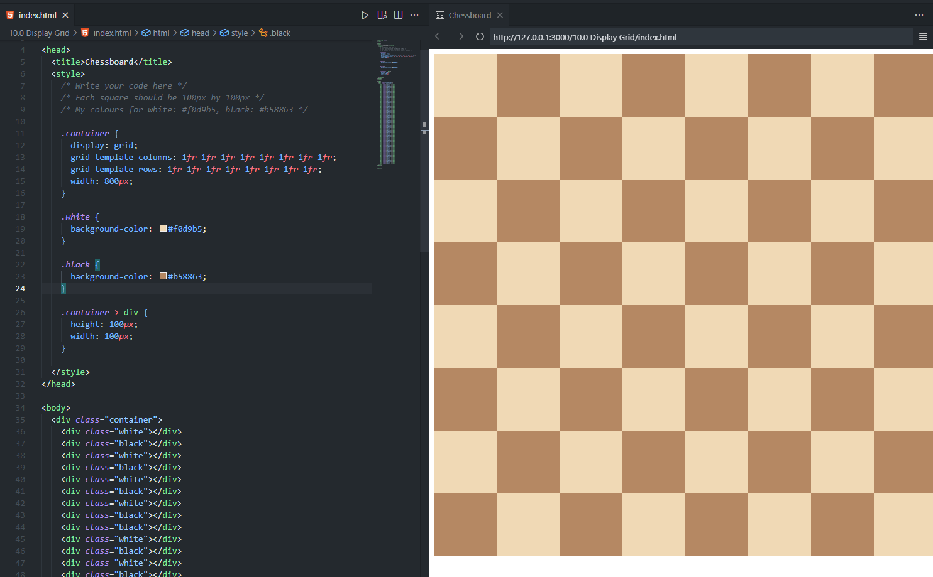

**Grid Sizing**

Not responsive

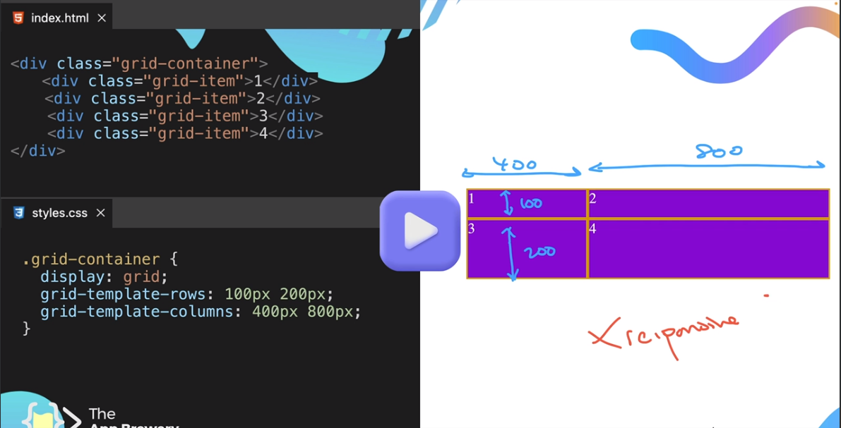

Short hand of grid template

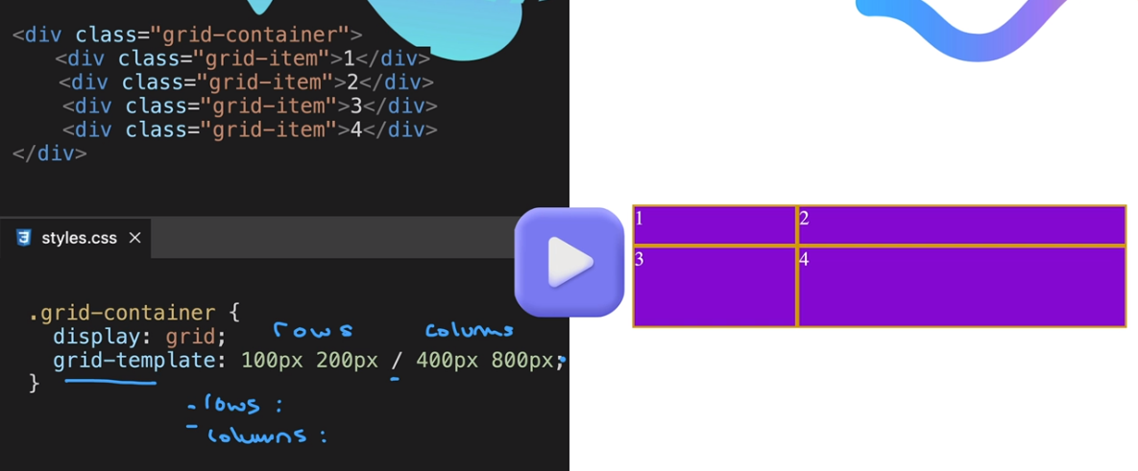

Below gives somehow responsiveness

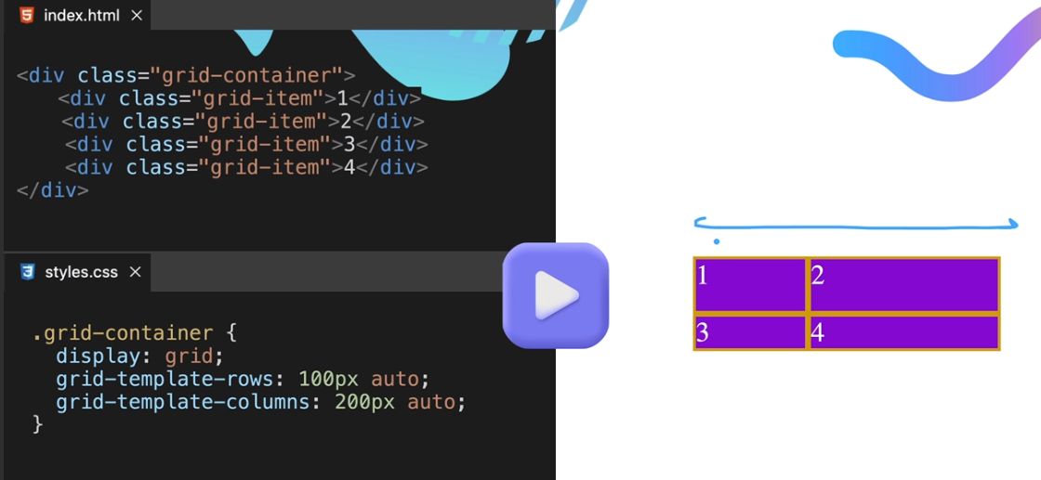

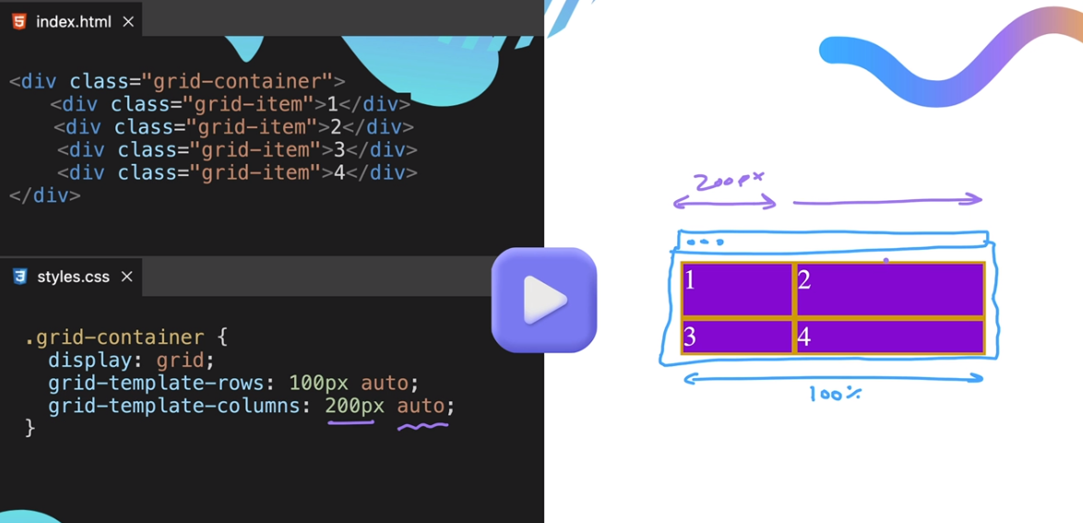

**Auto in row** is automatically fits to the **content** and not in height.

**Auto in column** is automatically fits to the website width size.

Take a look on this: [Grid Fundamentals (appbrewery.github.io)](https://appbrewery.github.io/grid-sizing/)

**Fractional Sizing**

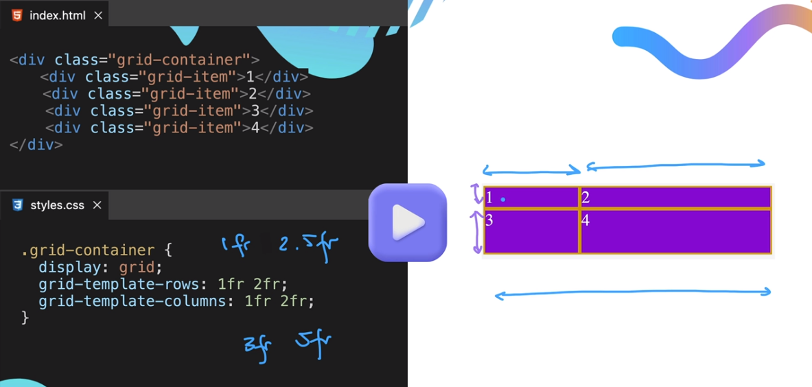

**MinMax**

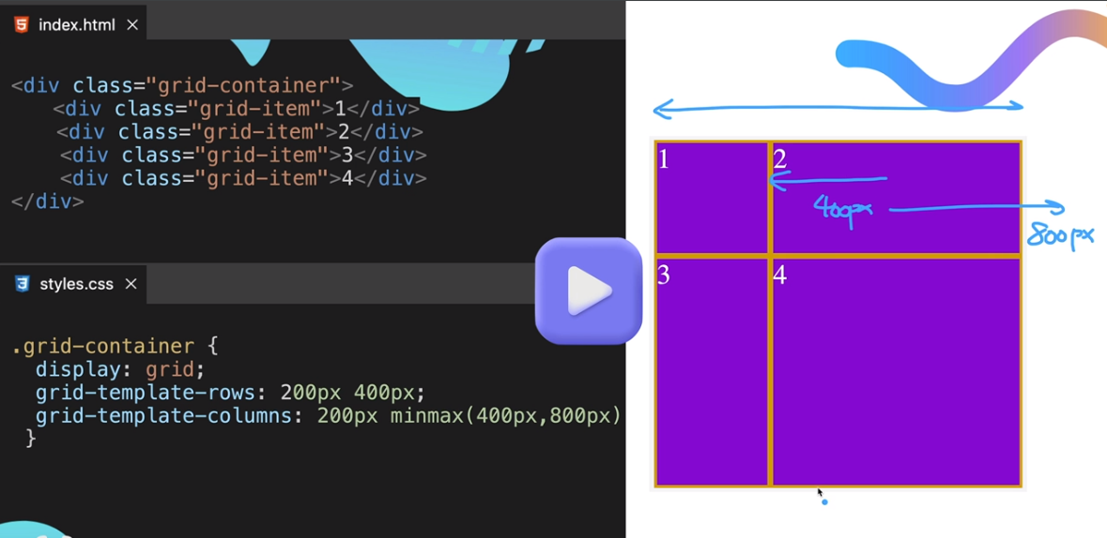

**Repeat**

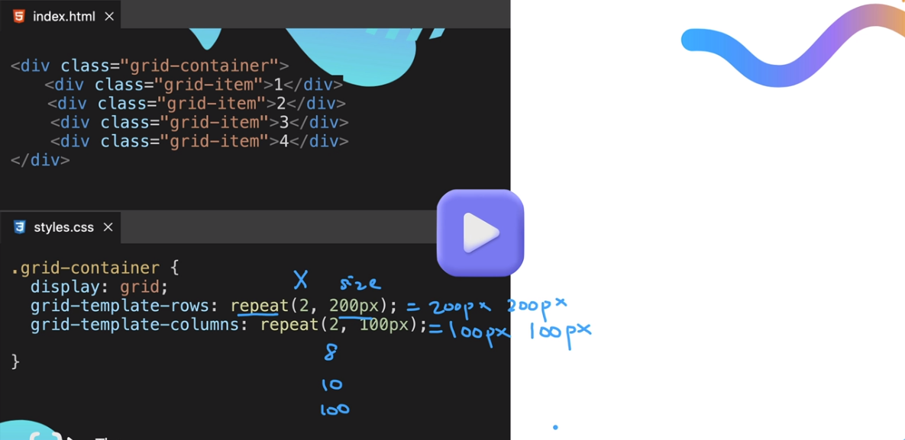

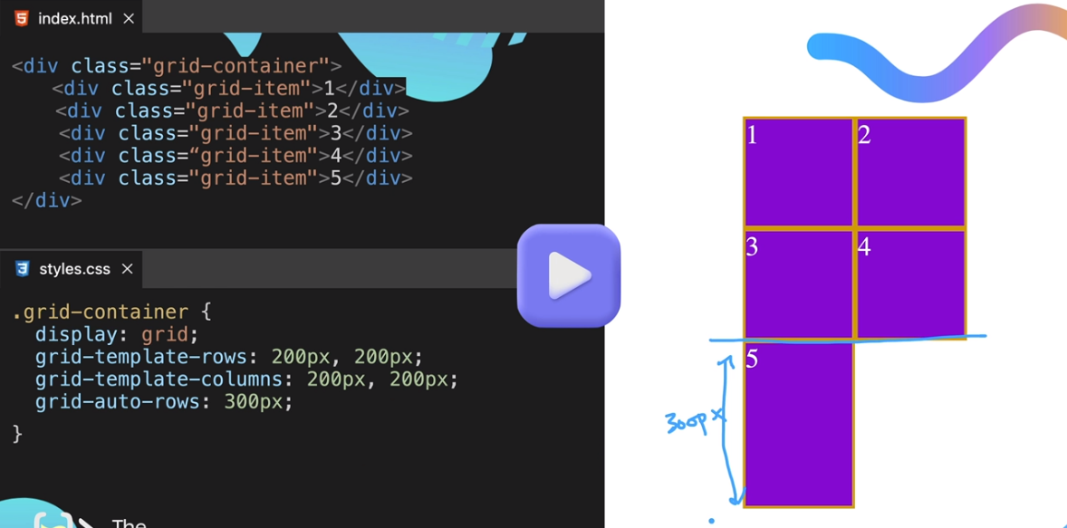

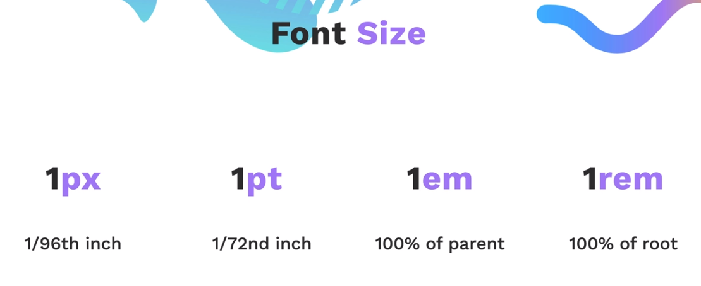

**GRID ITEM PLACEMENT**

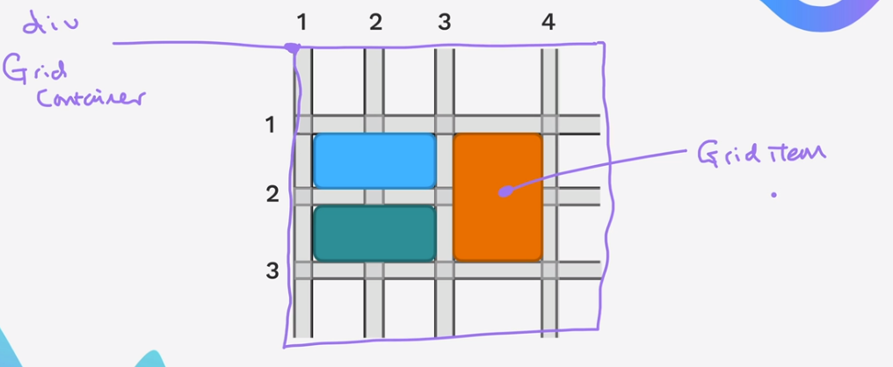

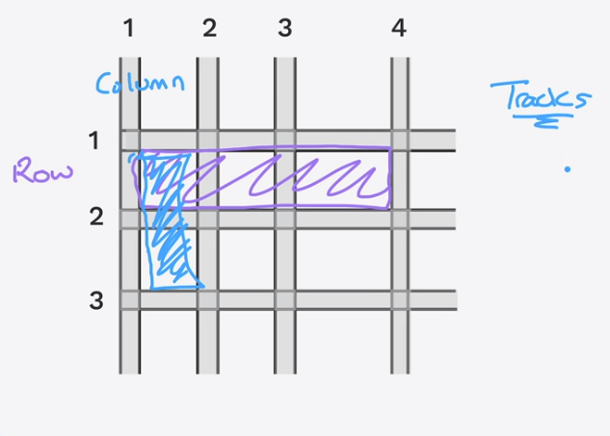

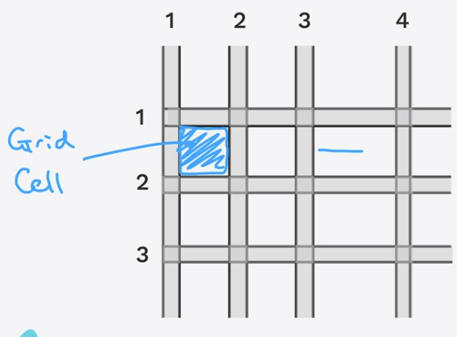

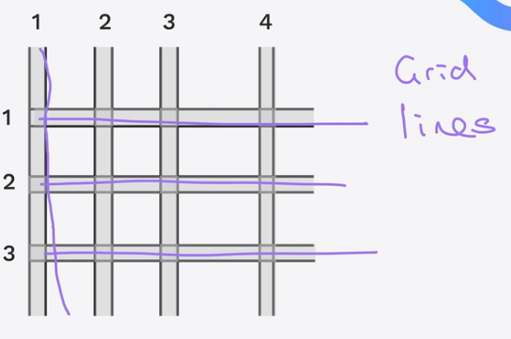

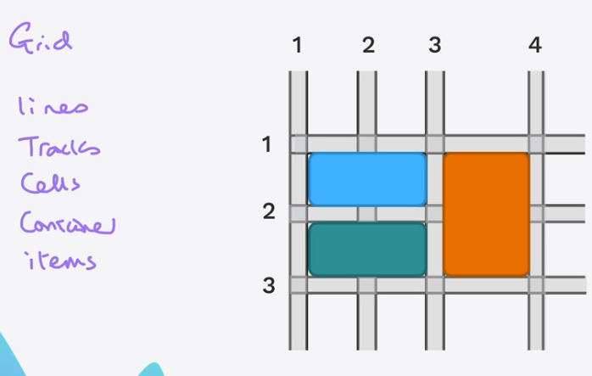

Sample

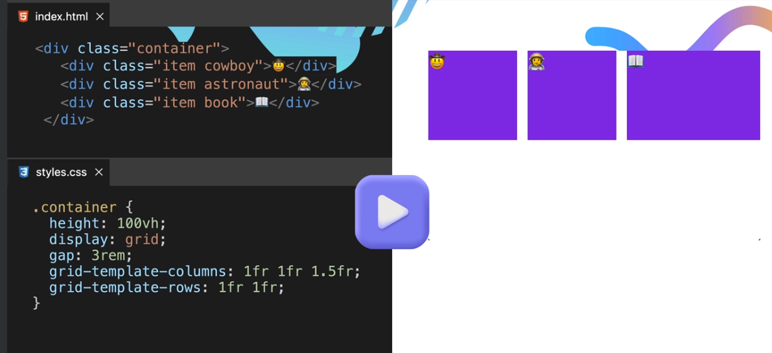

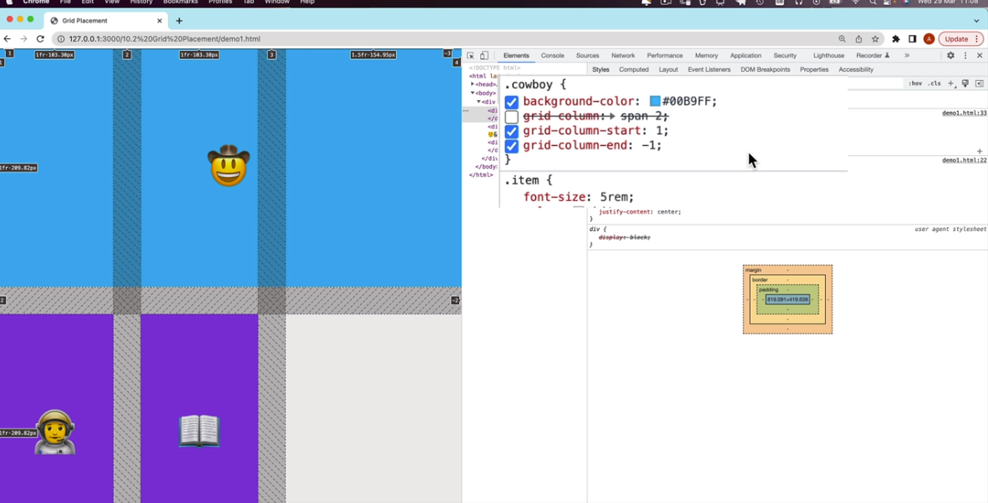

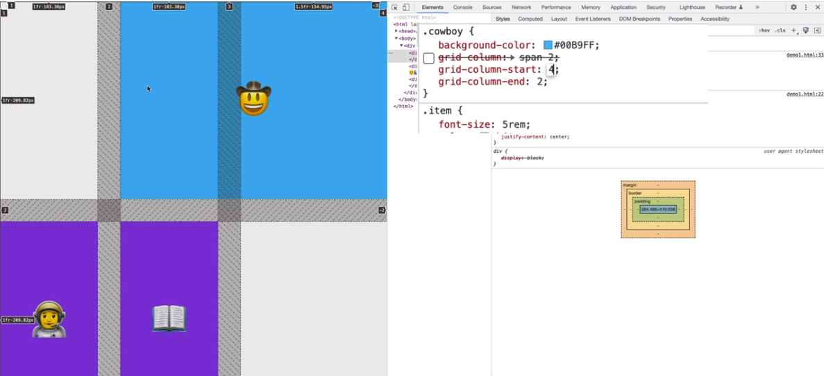

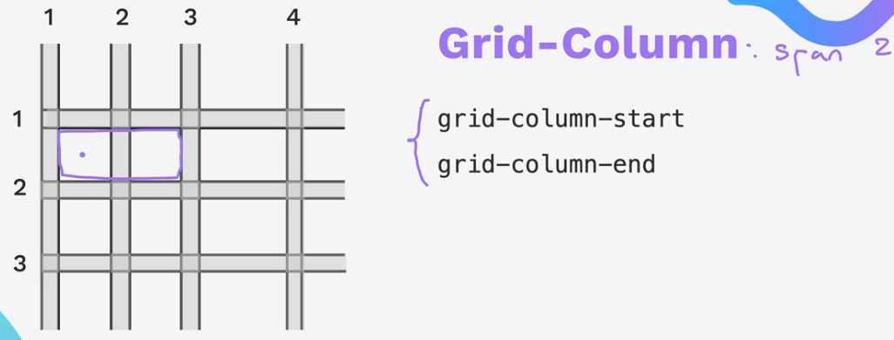

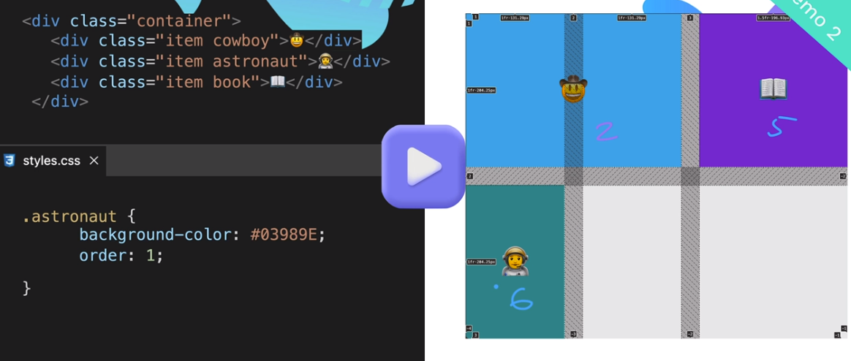

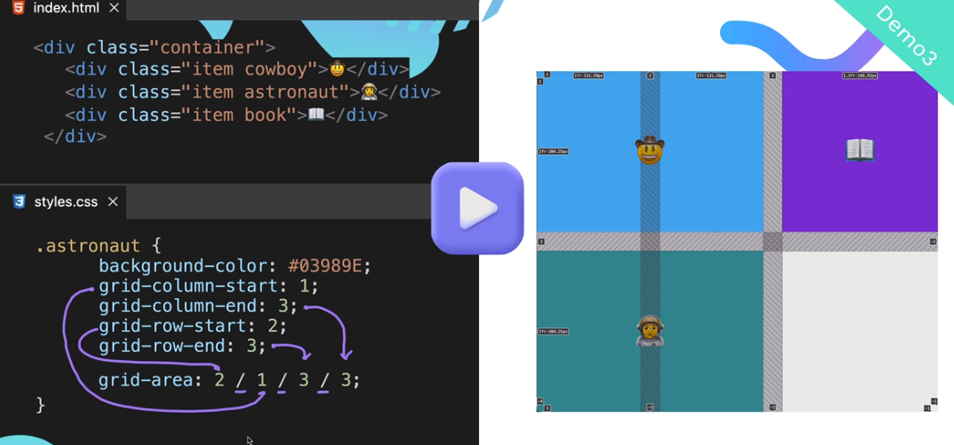

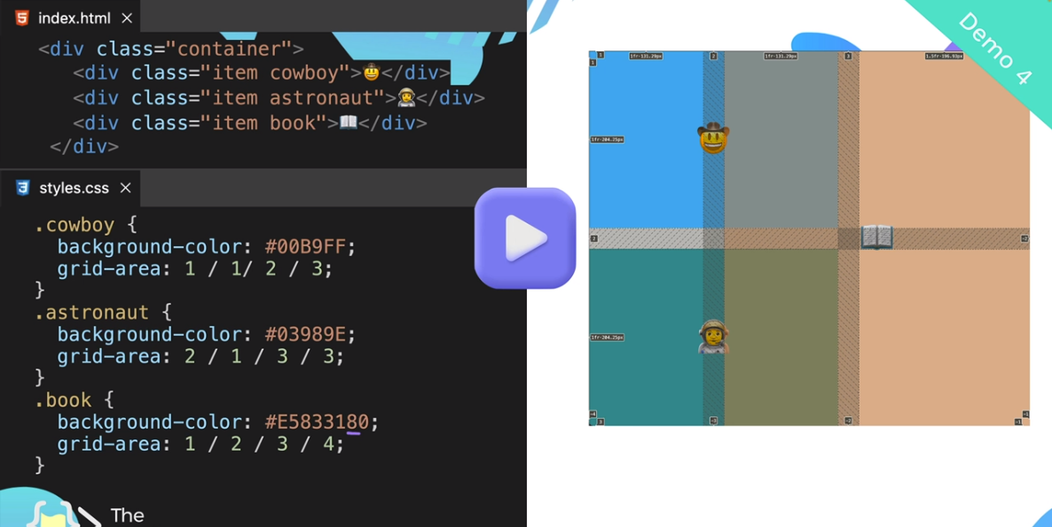

CHALLENGE APPLICATION: [Grid Garden - A game for learning CSS grid (appbrewery.github.io)](https://appbrewery.github.io/gridgarden/)

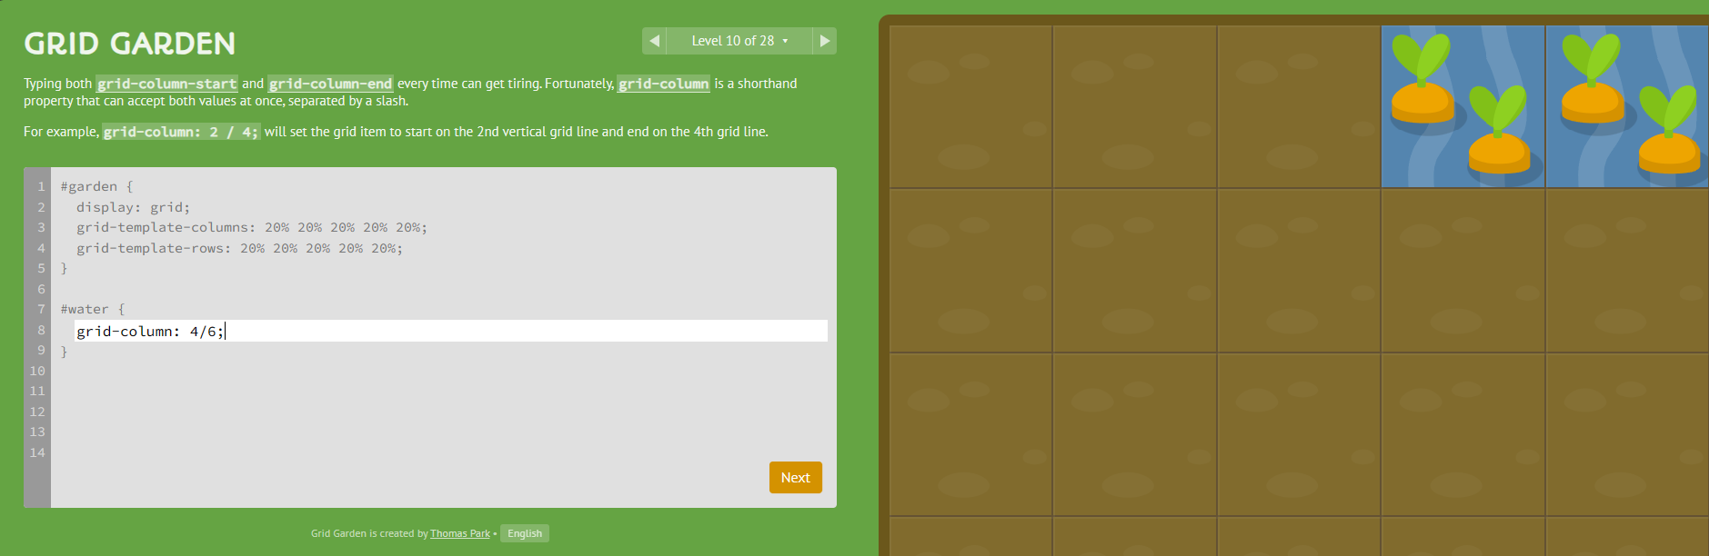

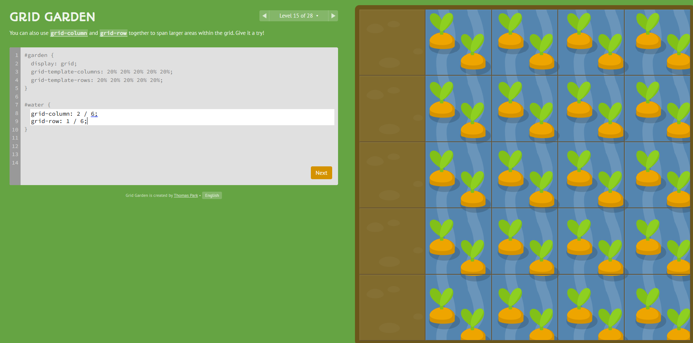

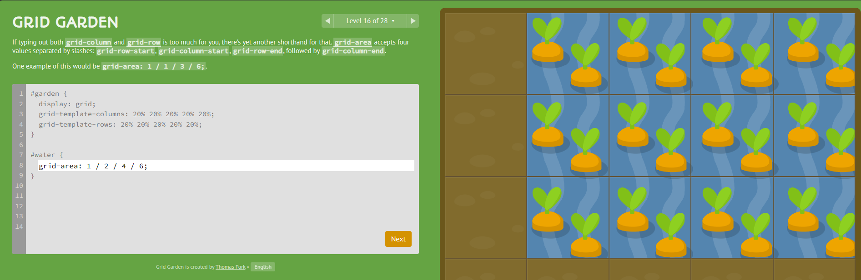

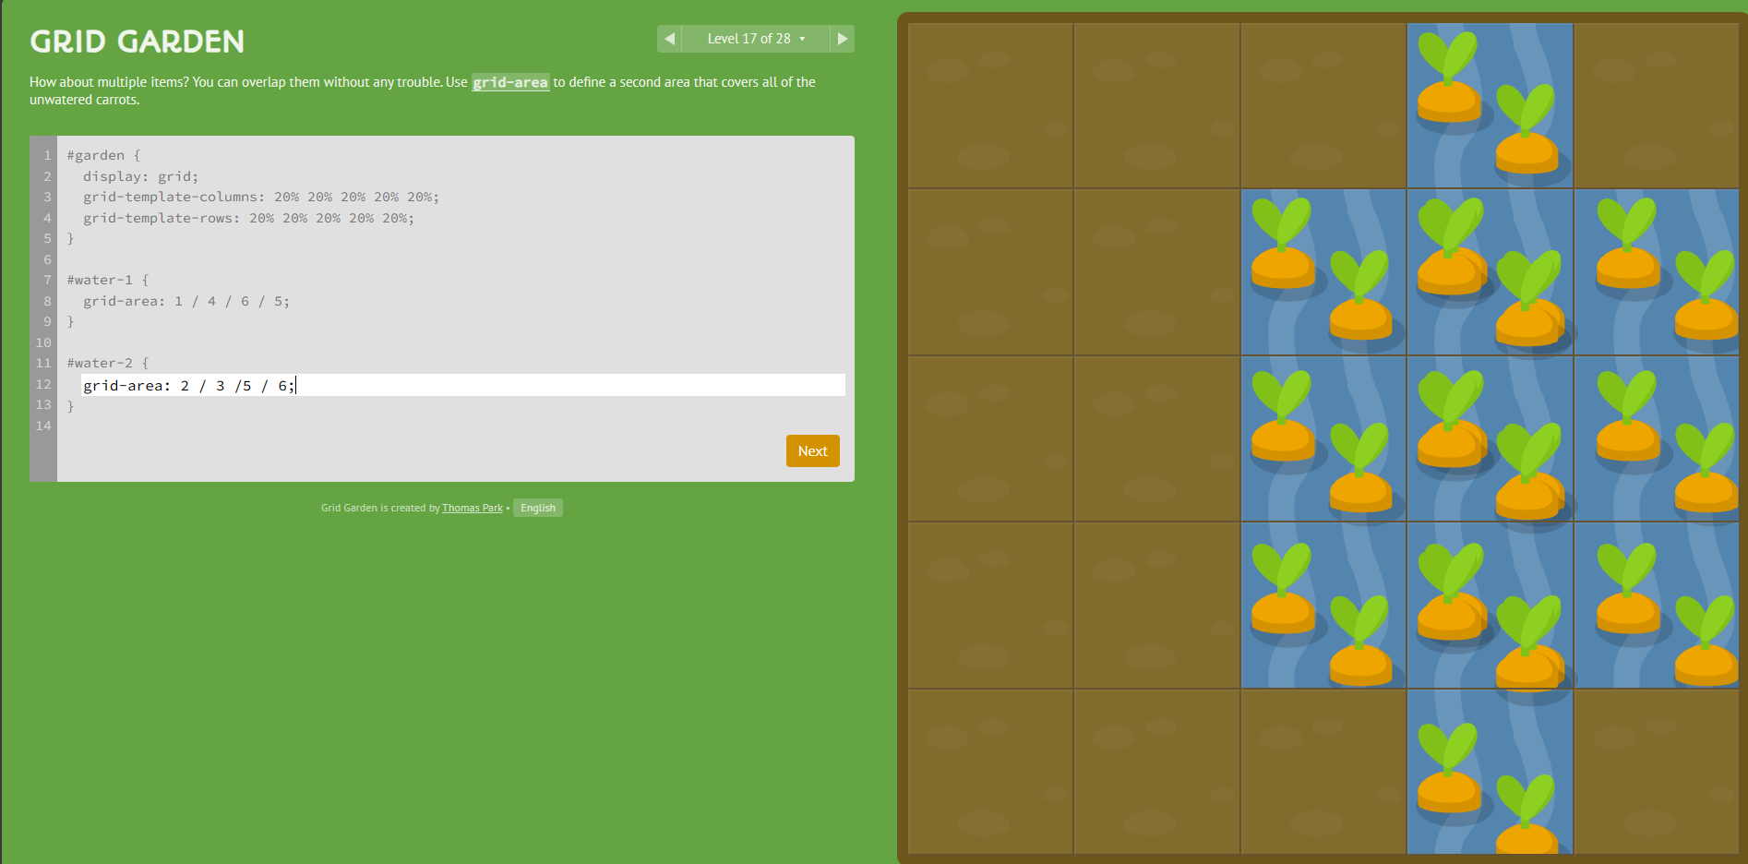

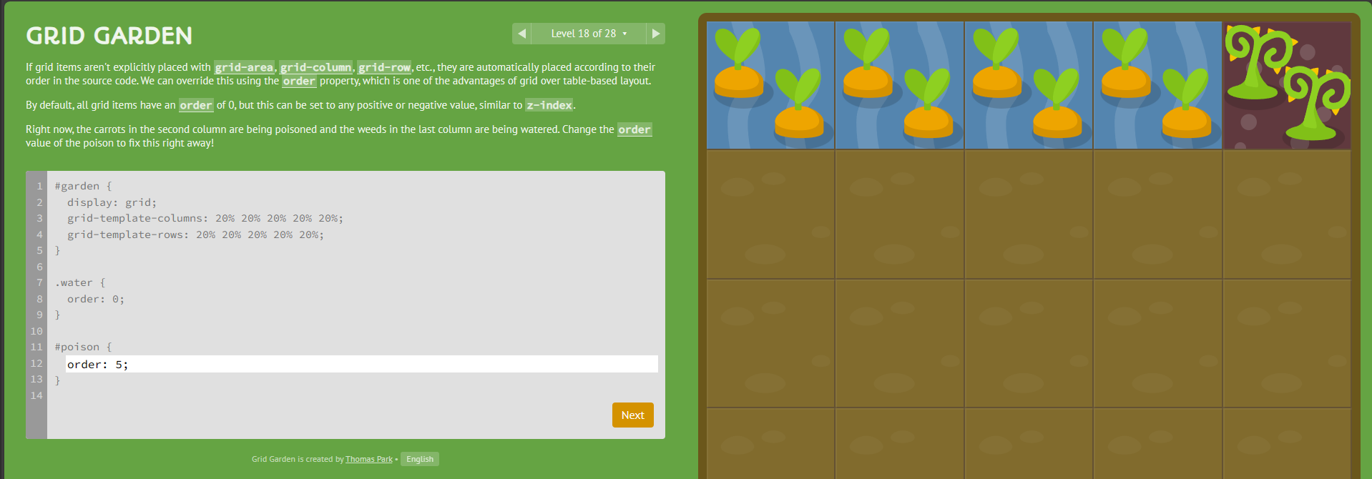

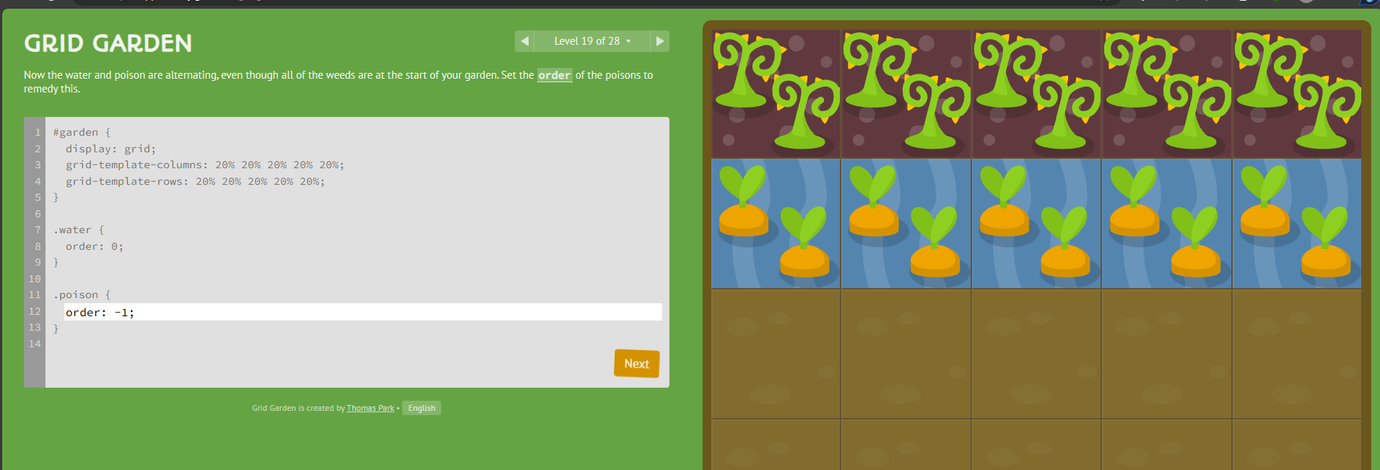

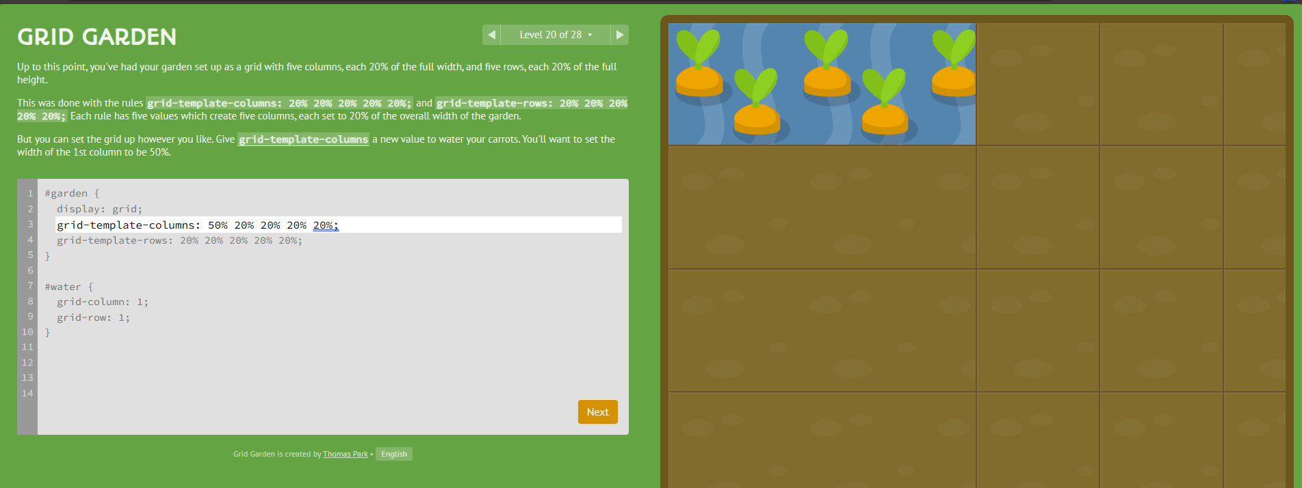

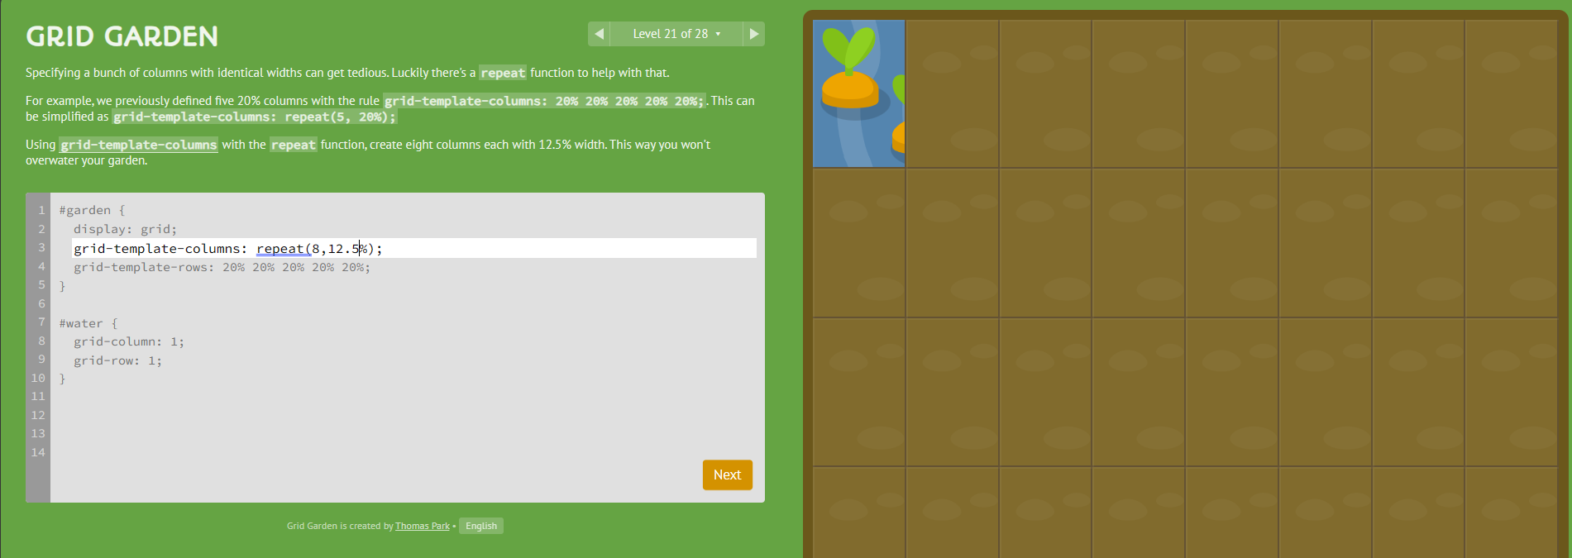

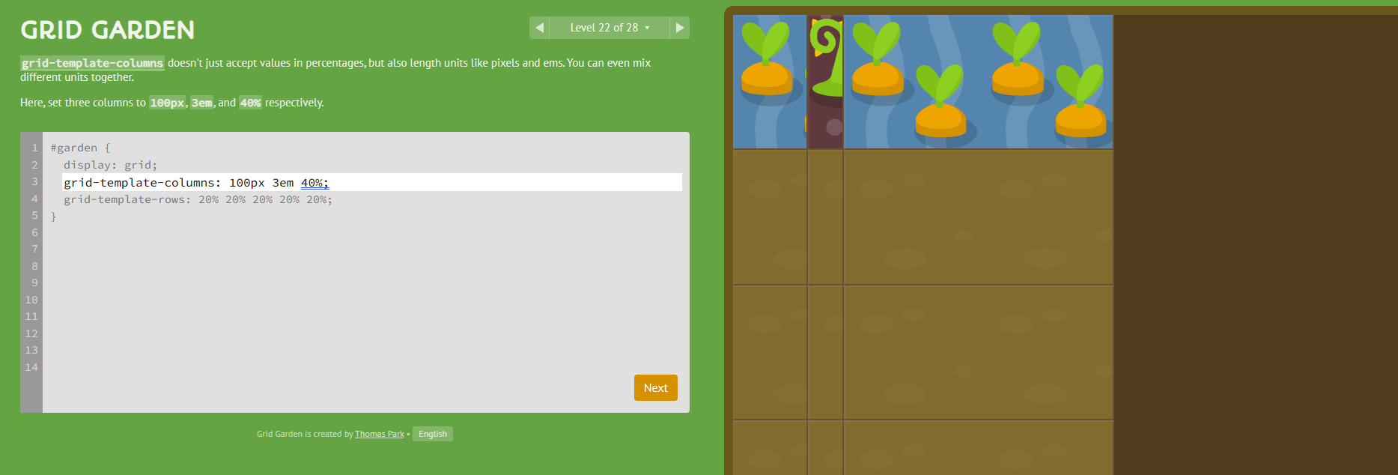

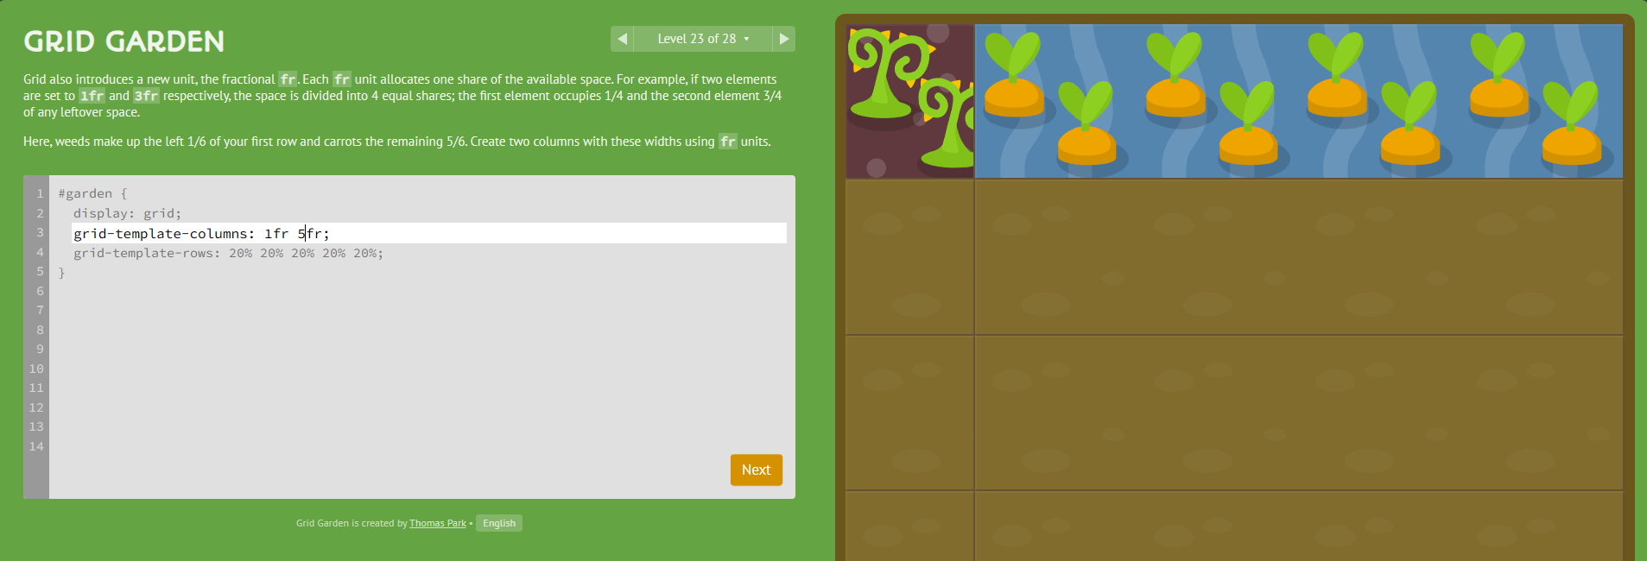

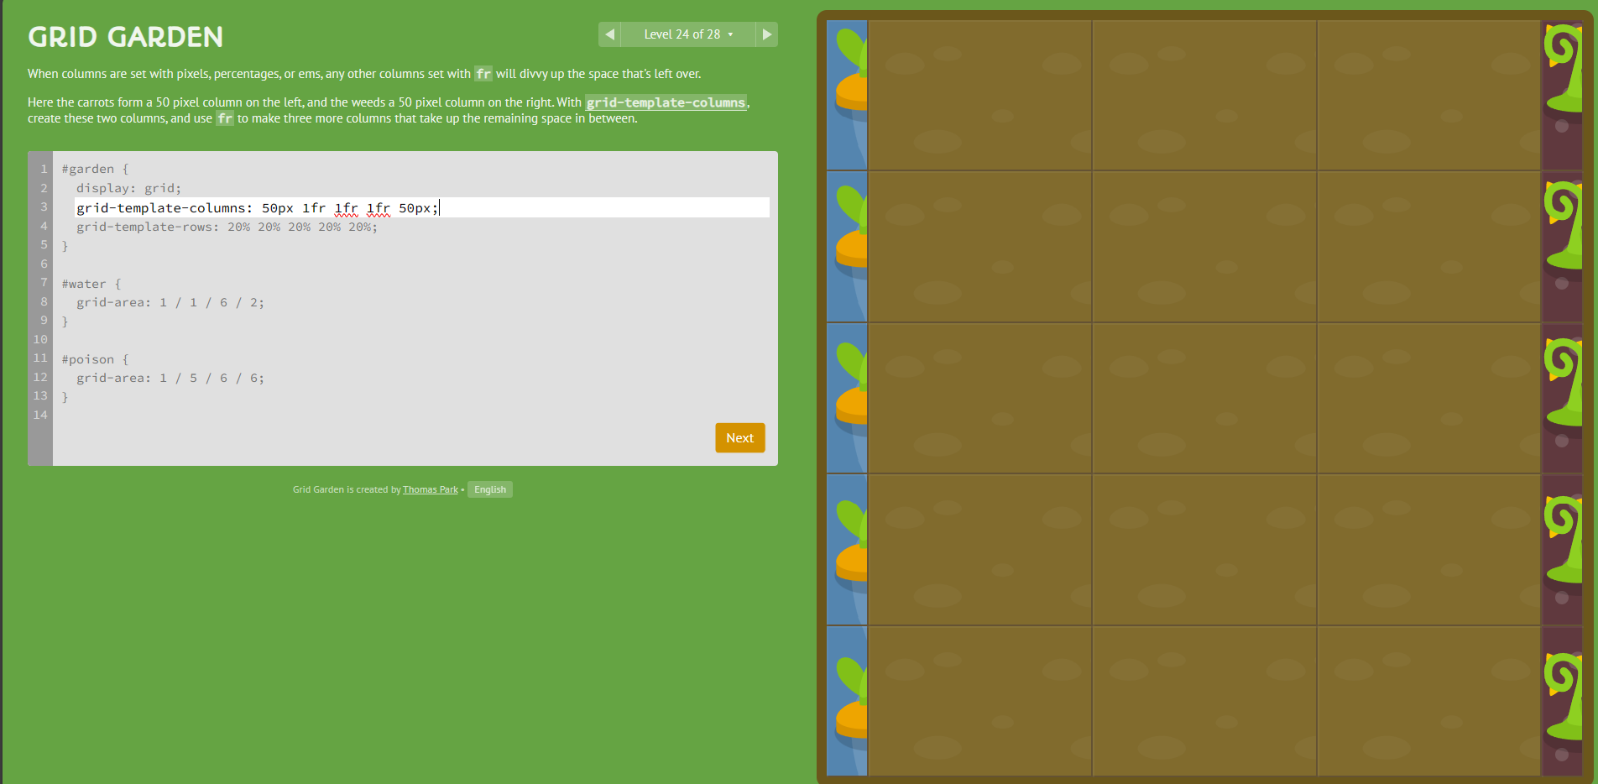



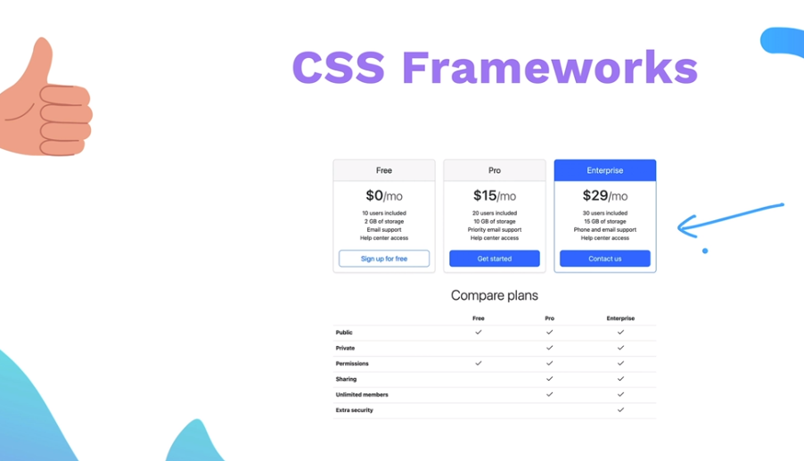

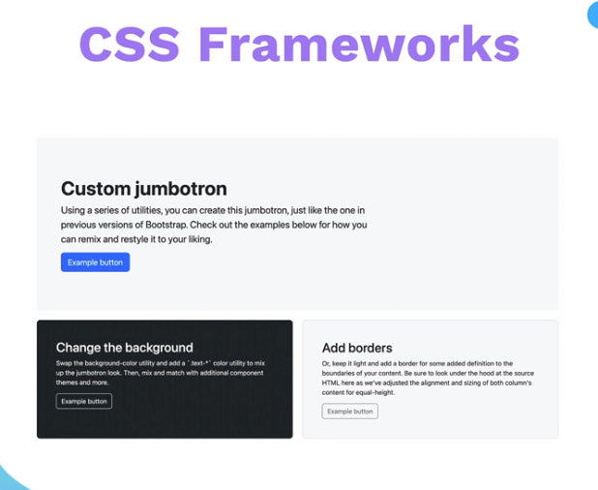

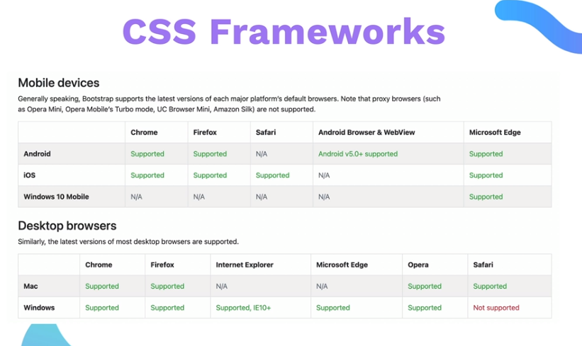

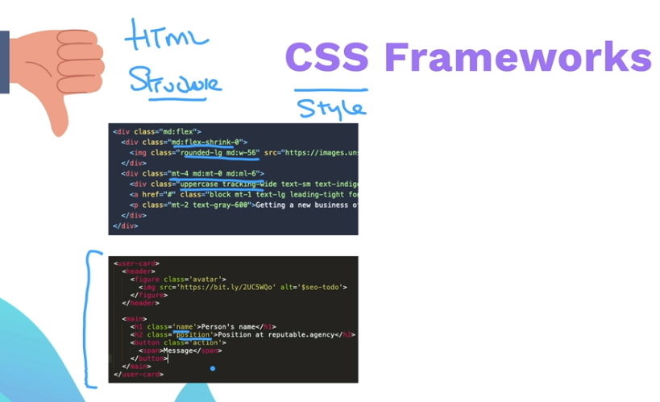

Class bloats: Downside

Customization: Downside

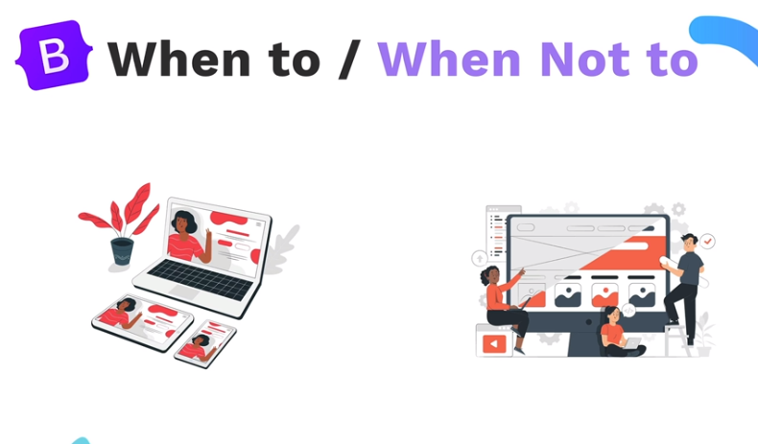

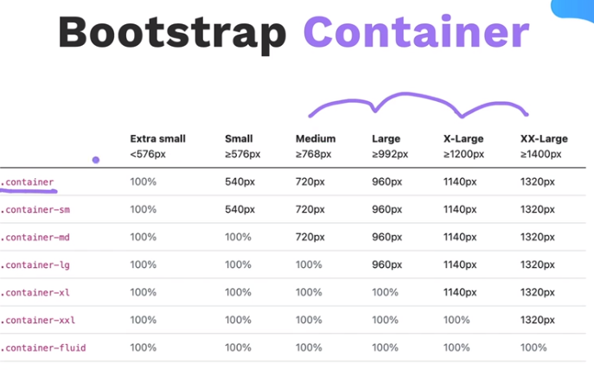

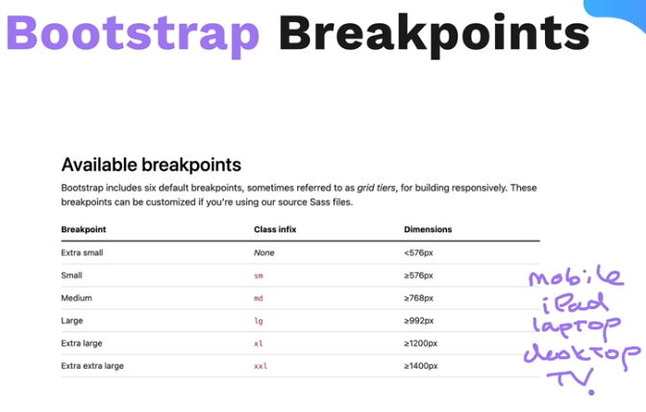

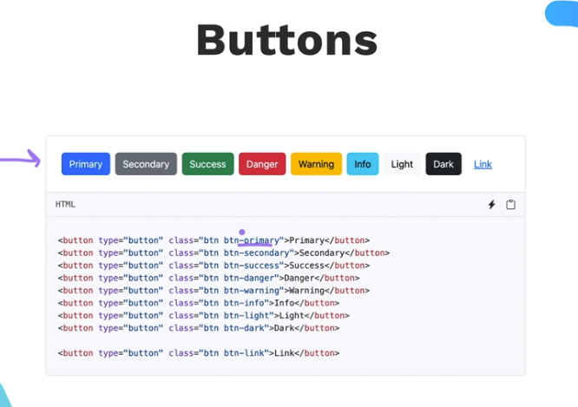

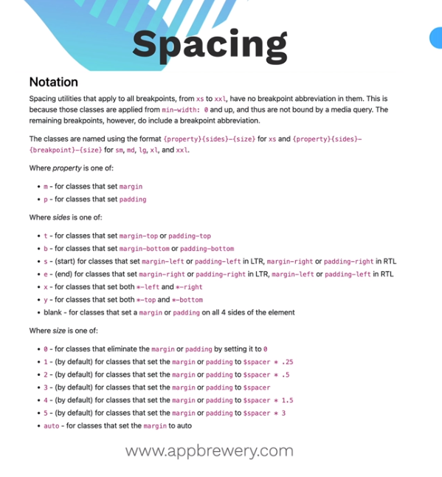

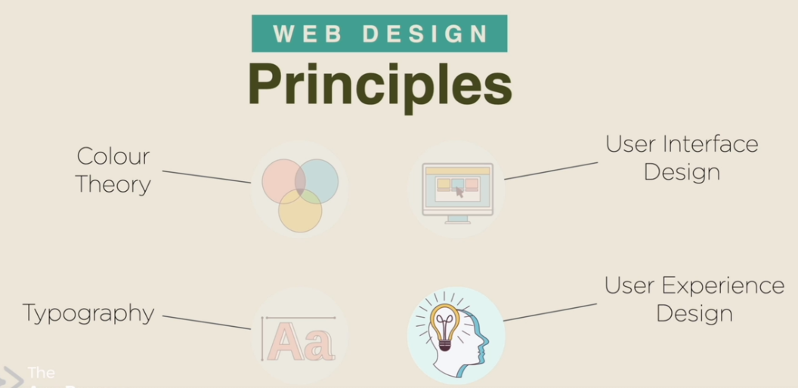

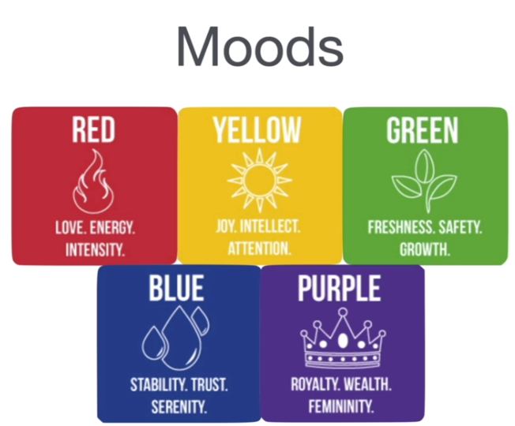

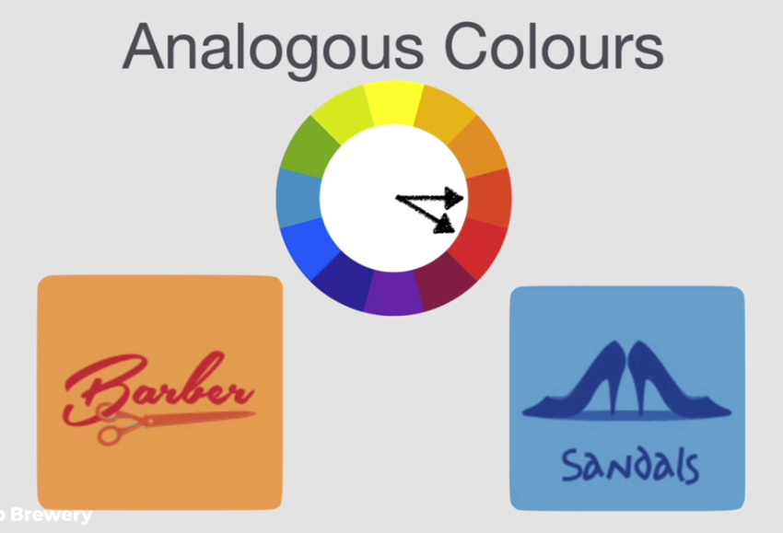

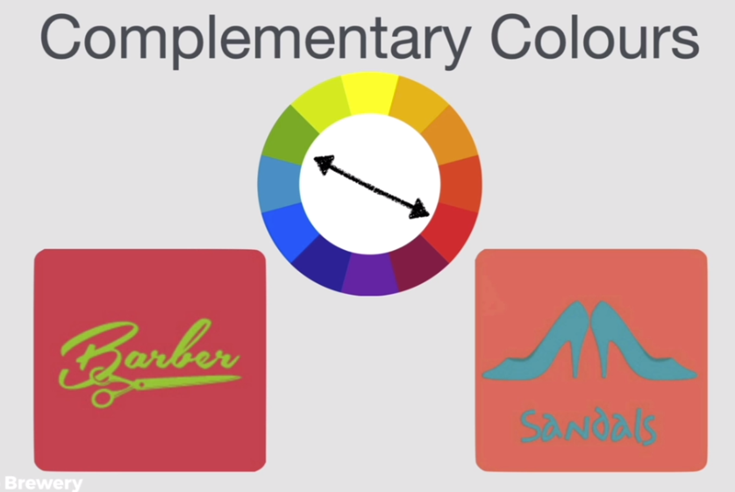 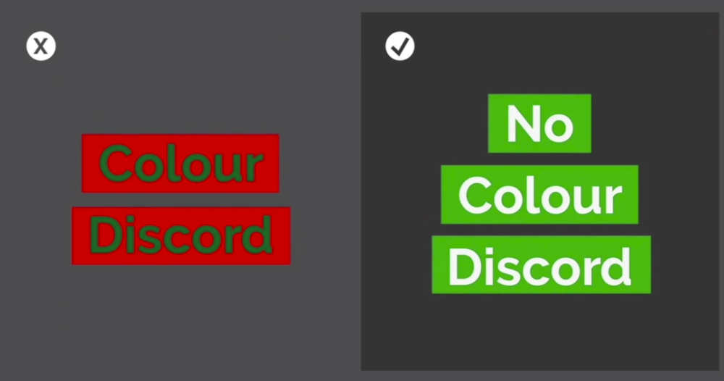

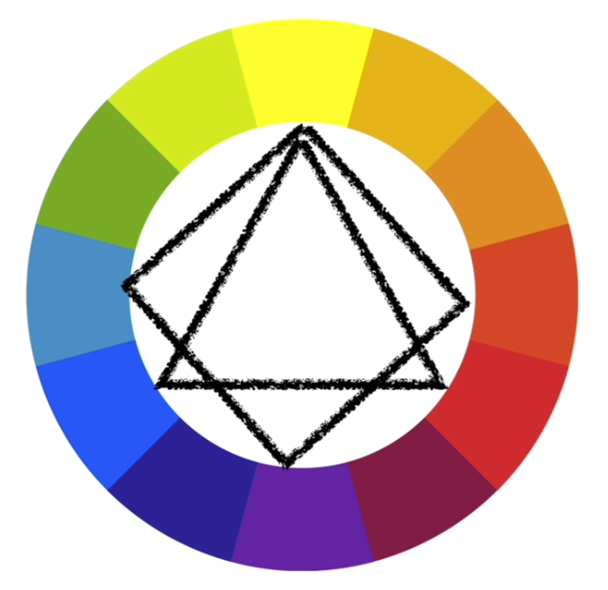

Reference for Colors:

[Color Palettes for Designers and Artists - Color Hunt](https://colorhunt.co/)

[Color wheel, a color palette generator | Adobe Color](https://color.adobe.com/create/color-wheel)

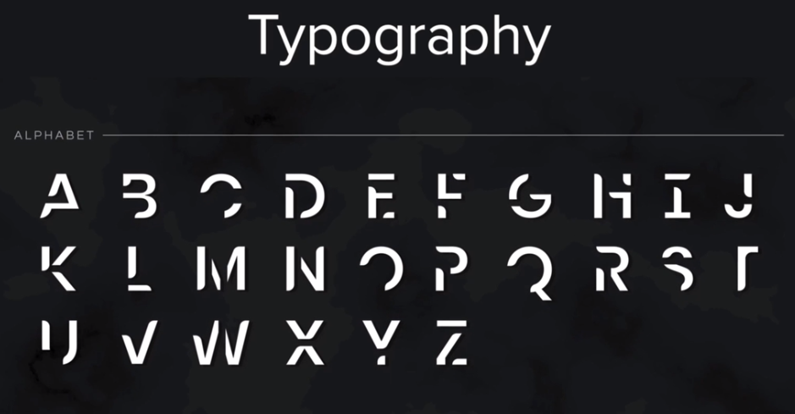

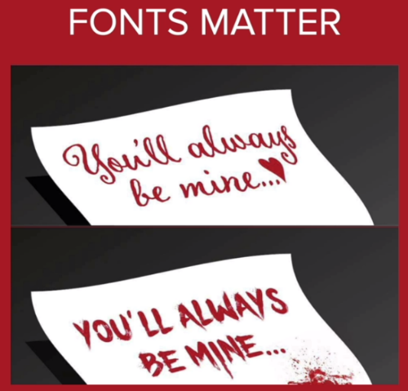

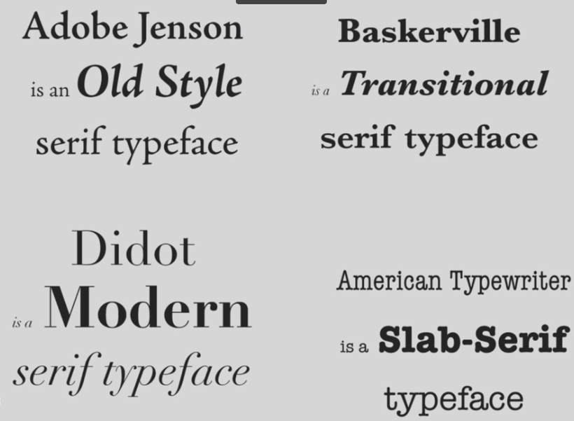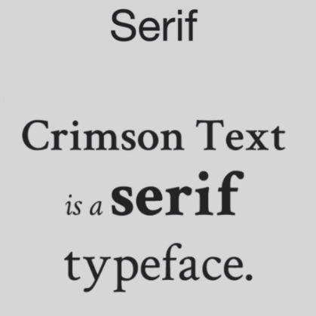

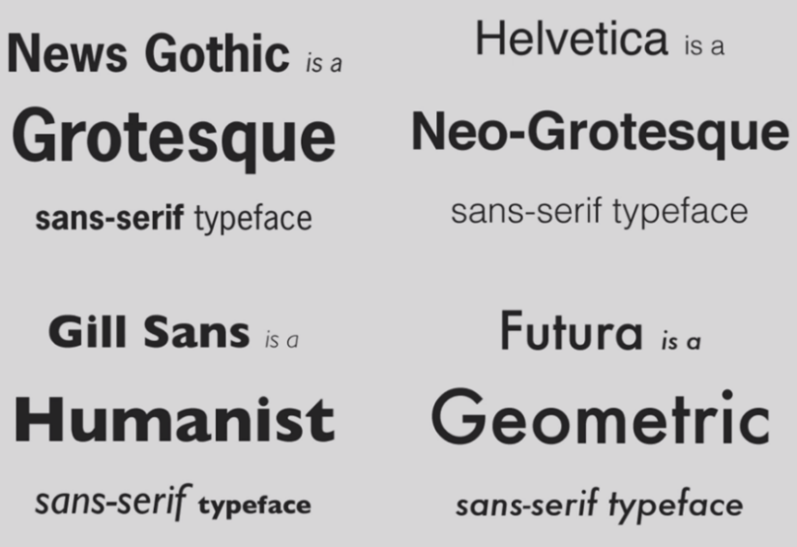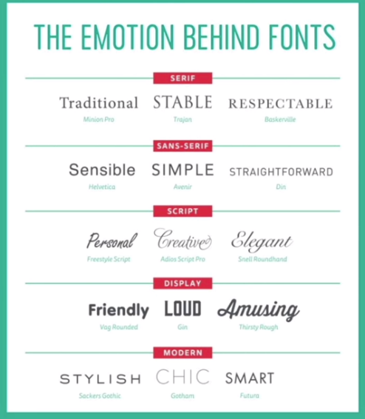

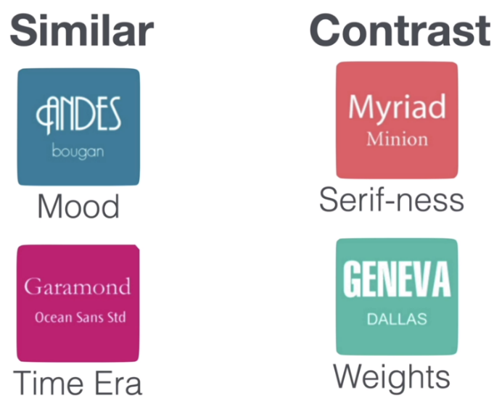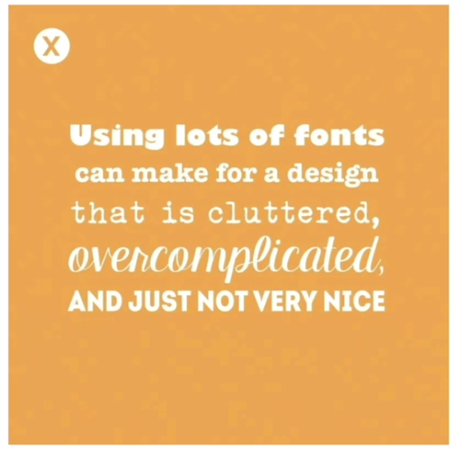

DO NOT USE THE FF FONTS:

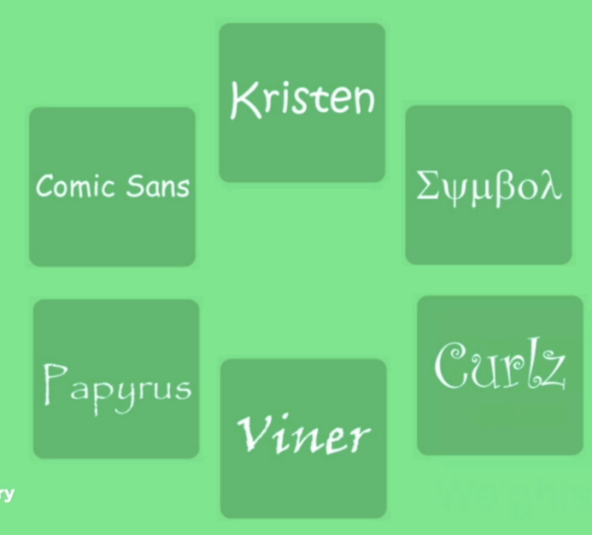



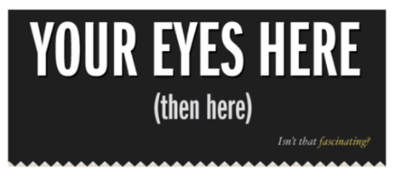

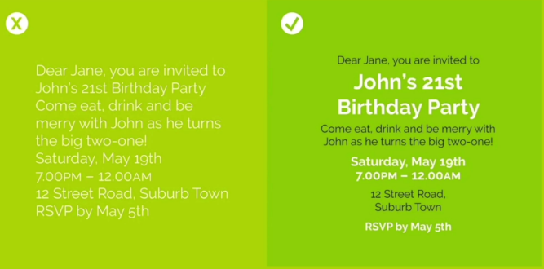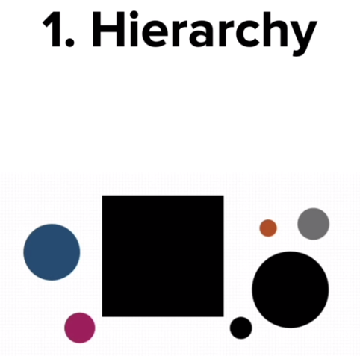

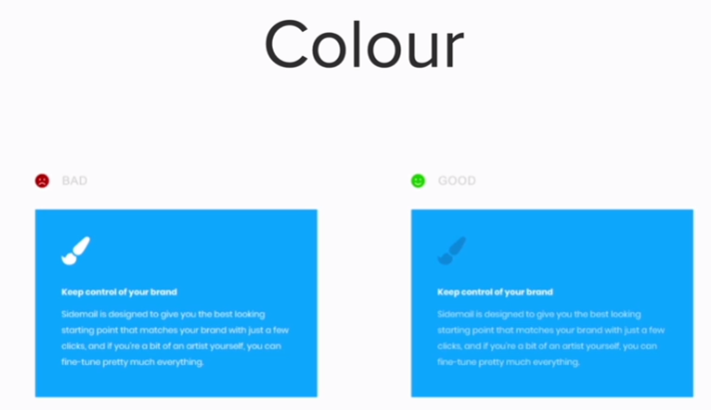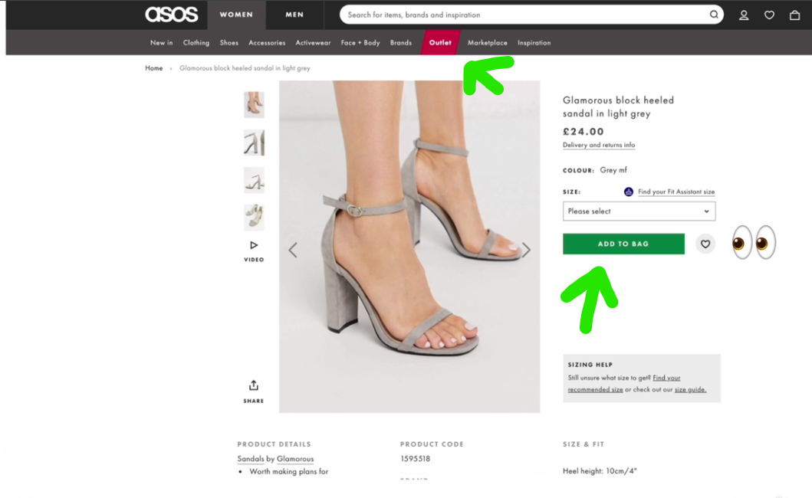

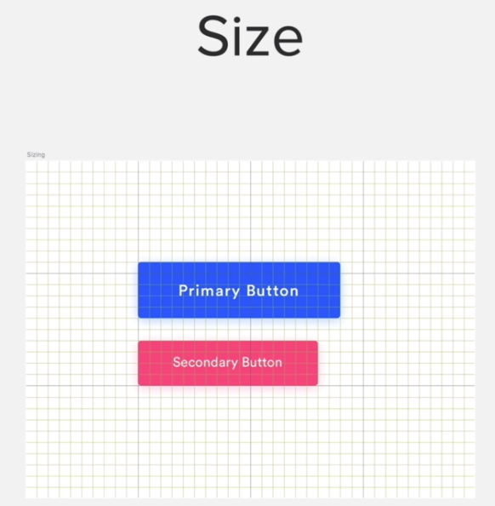

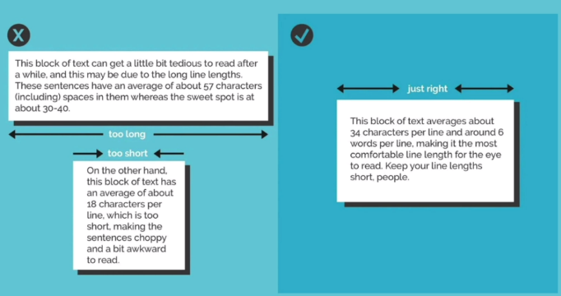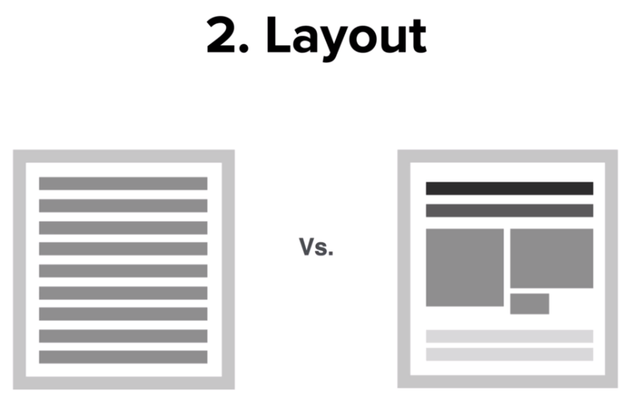

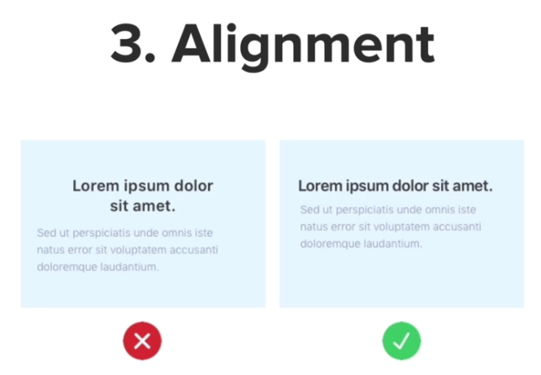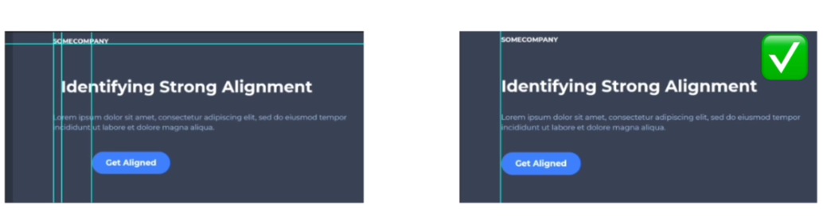

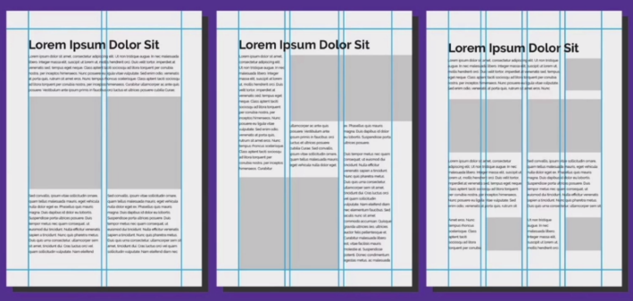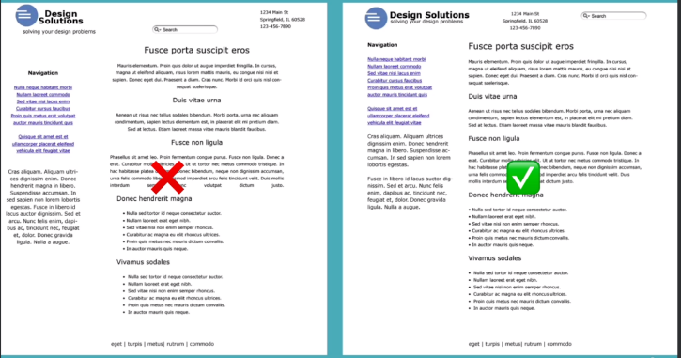

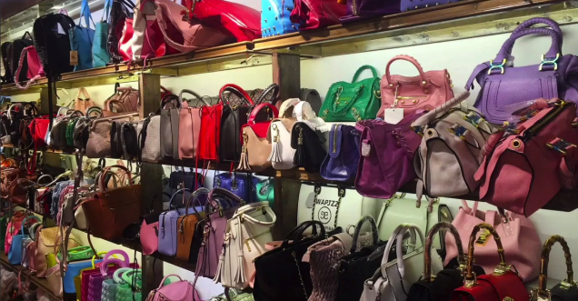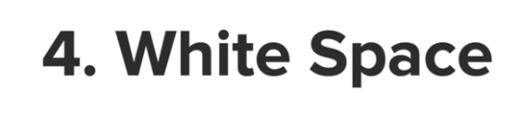



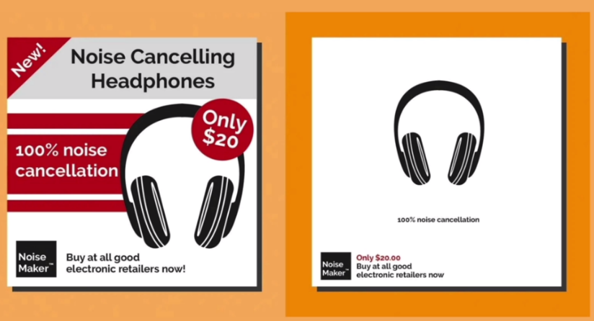

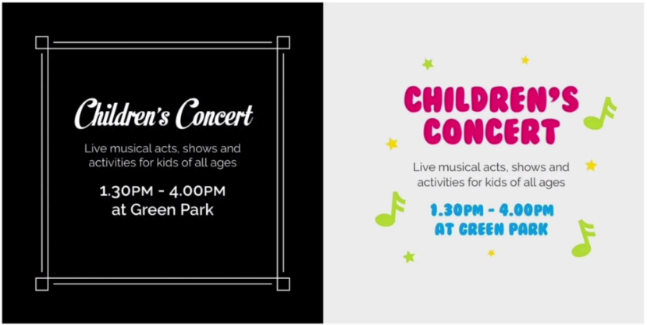





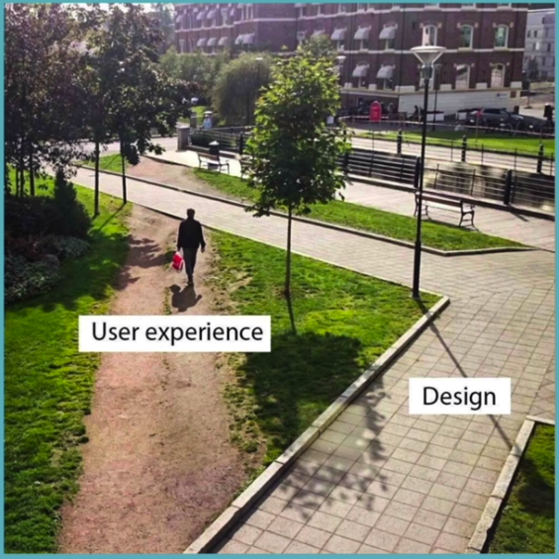

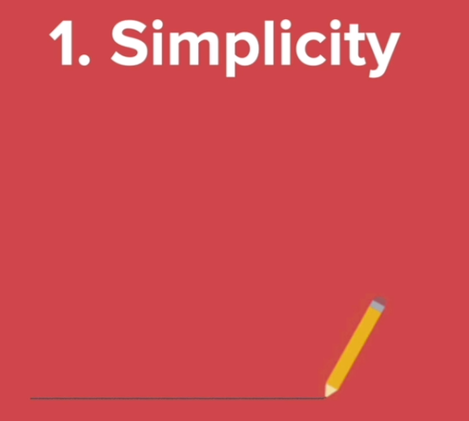

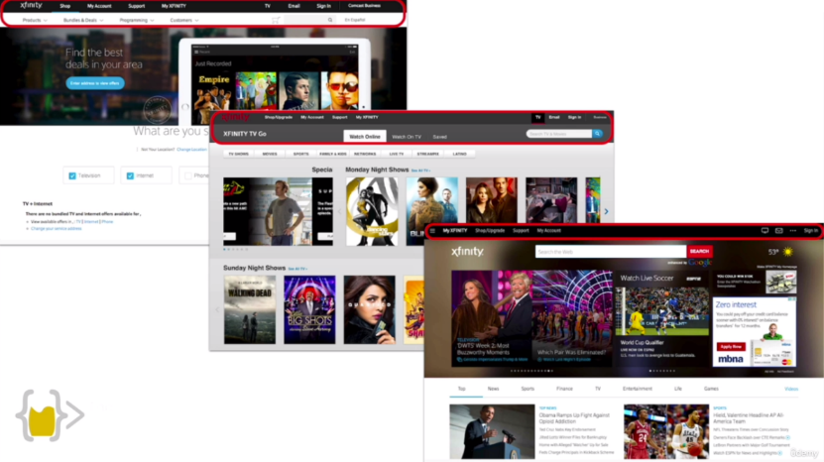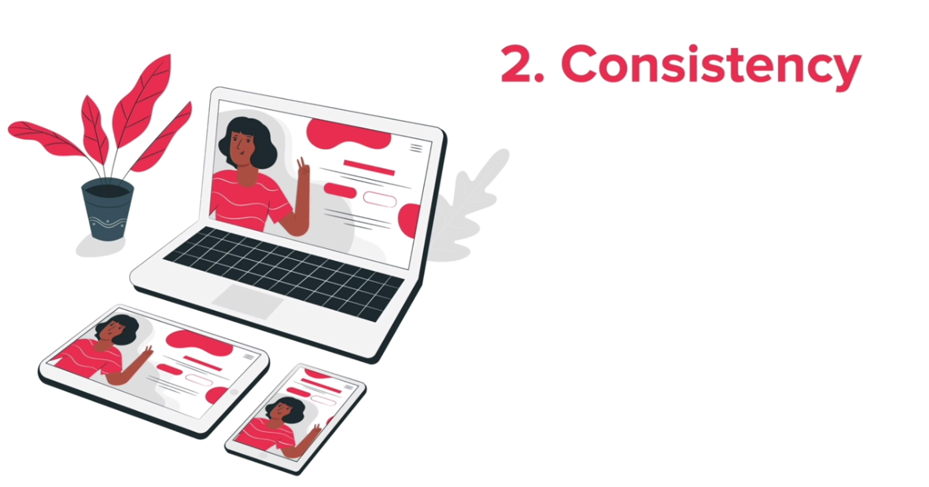

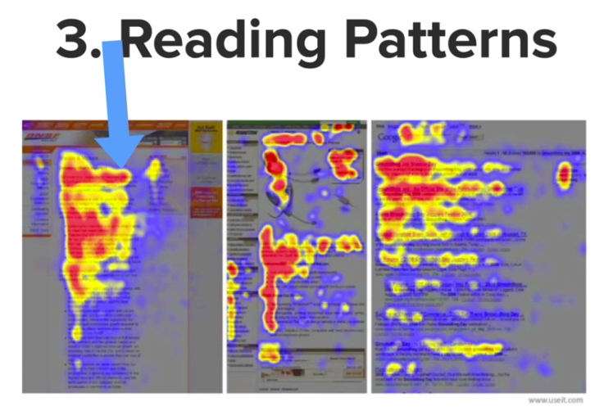

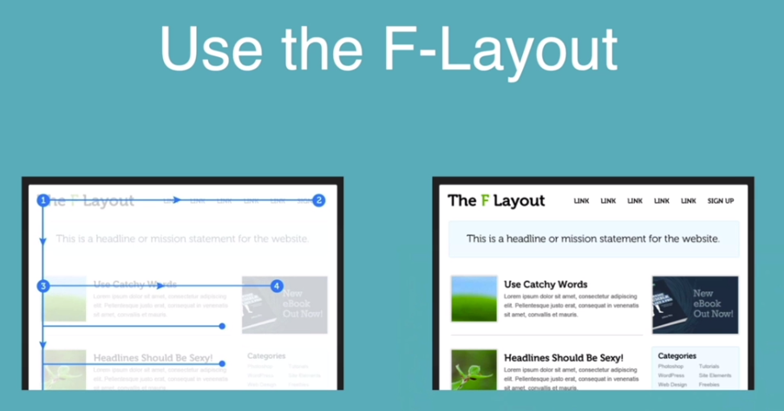

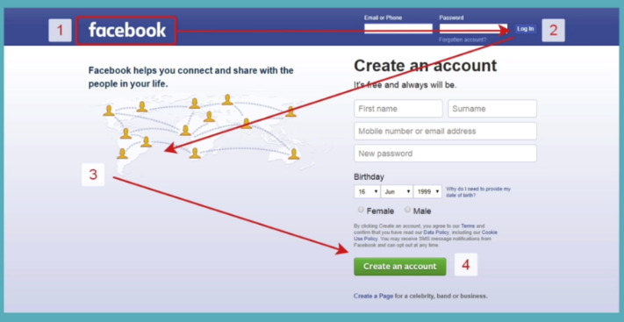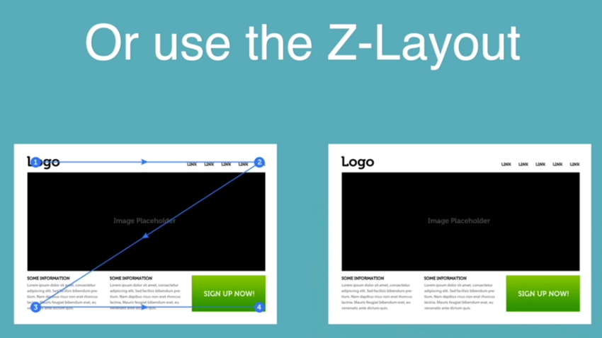

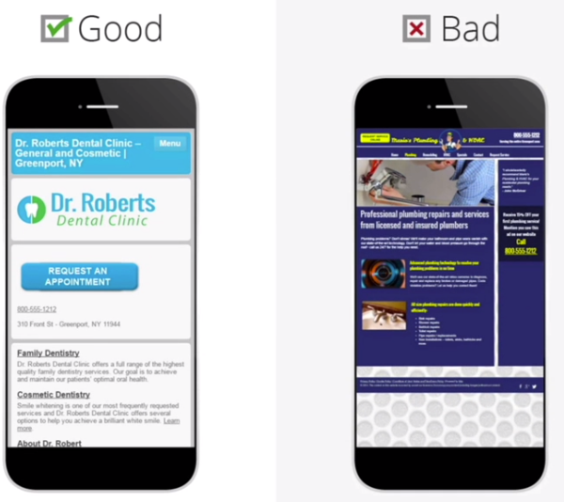



**4.**

